
Jenkins Task -4
- Setup Jenkins CICD pipeline using freestyle job using Docker containers using below code. https://github.com/betawins/hiring-app.git Stages:
Git Clone
SonarQube Integration
Maven Compilation
Nexus Artifactory
Slack Notification
Deploy On tomcat
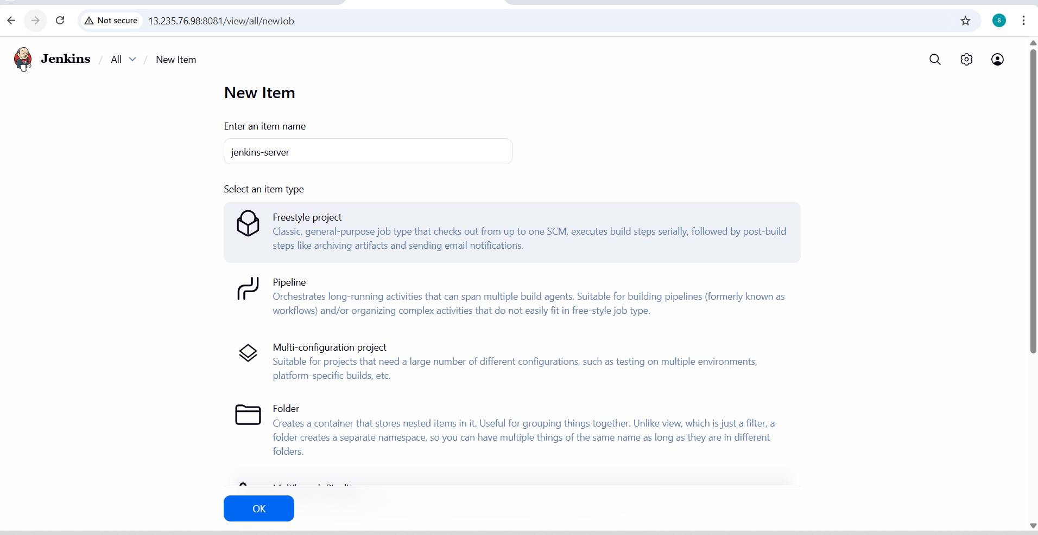

- Source manager configure

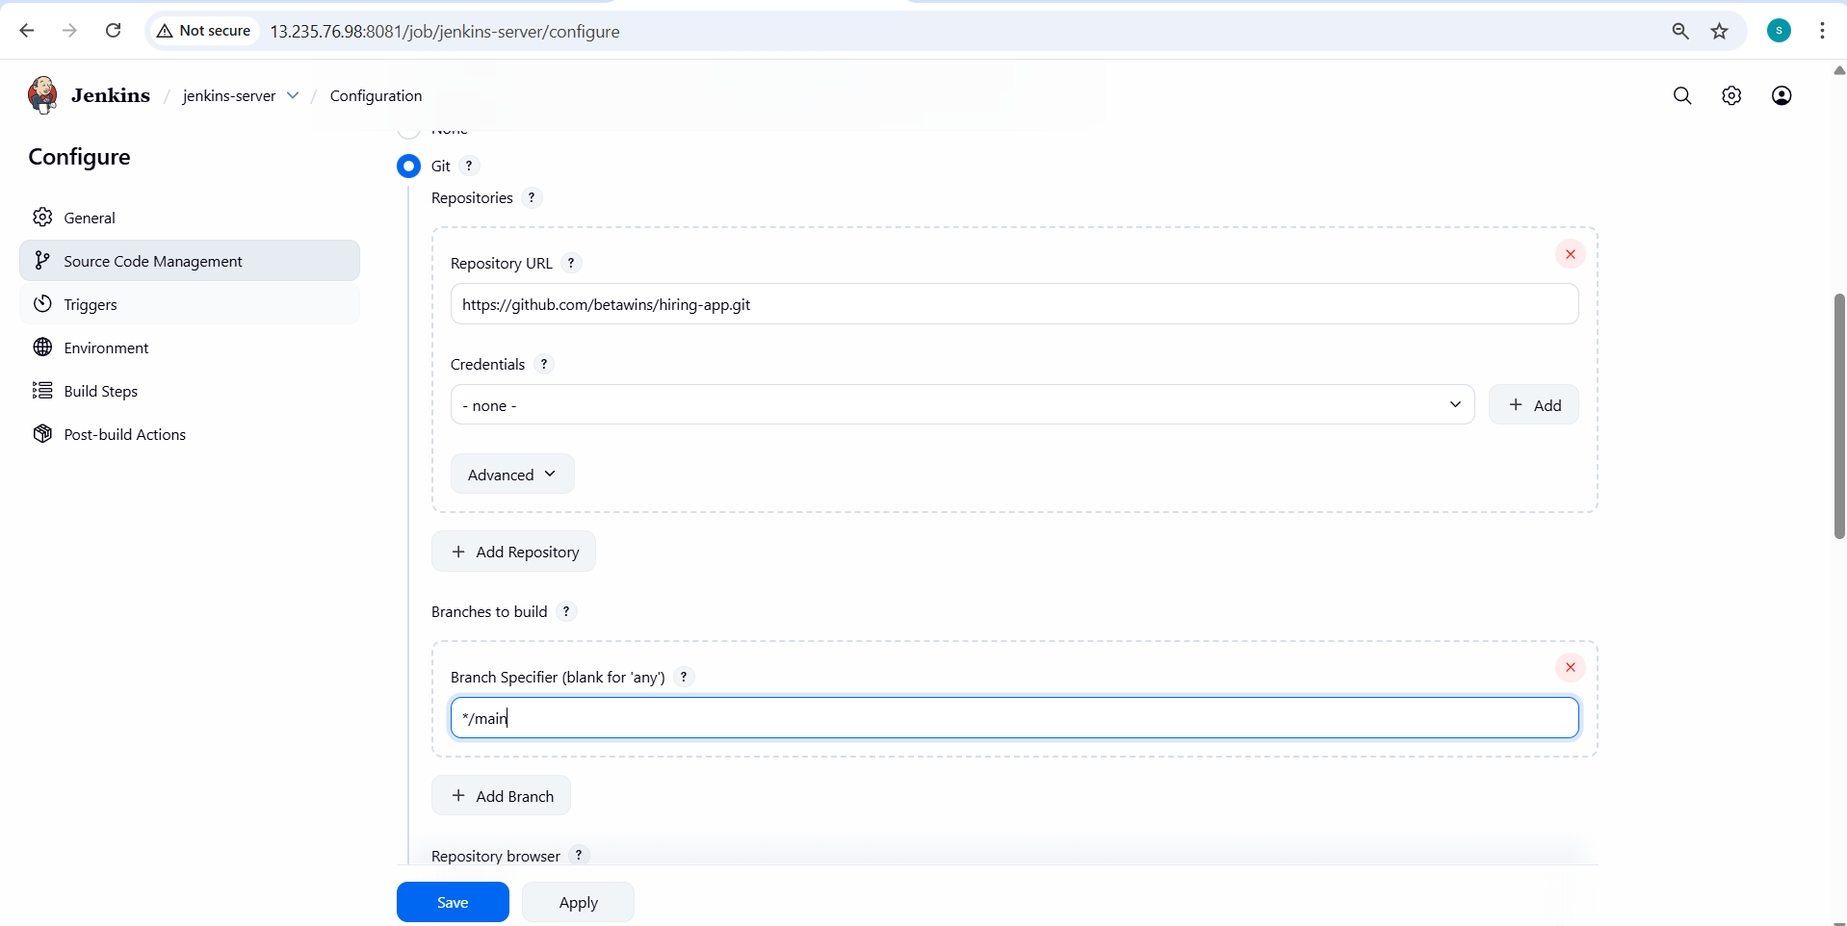
- Repository is cloned successfully
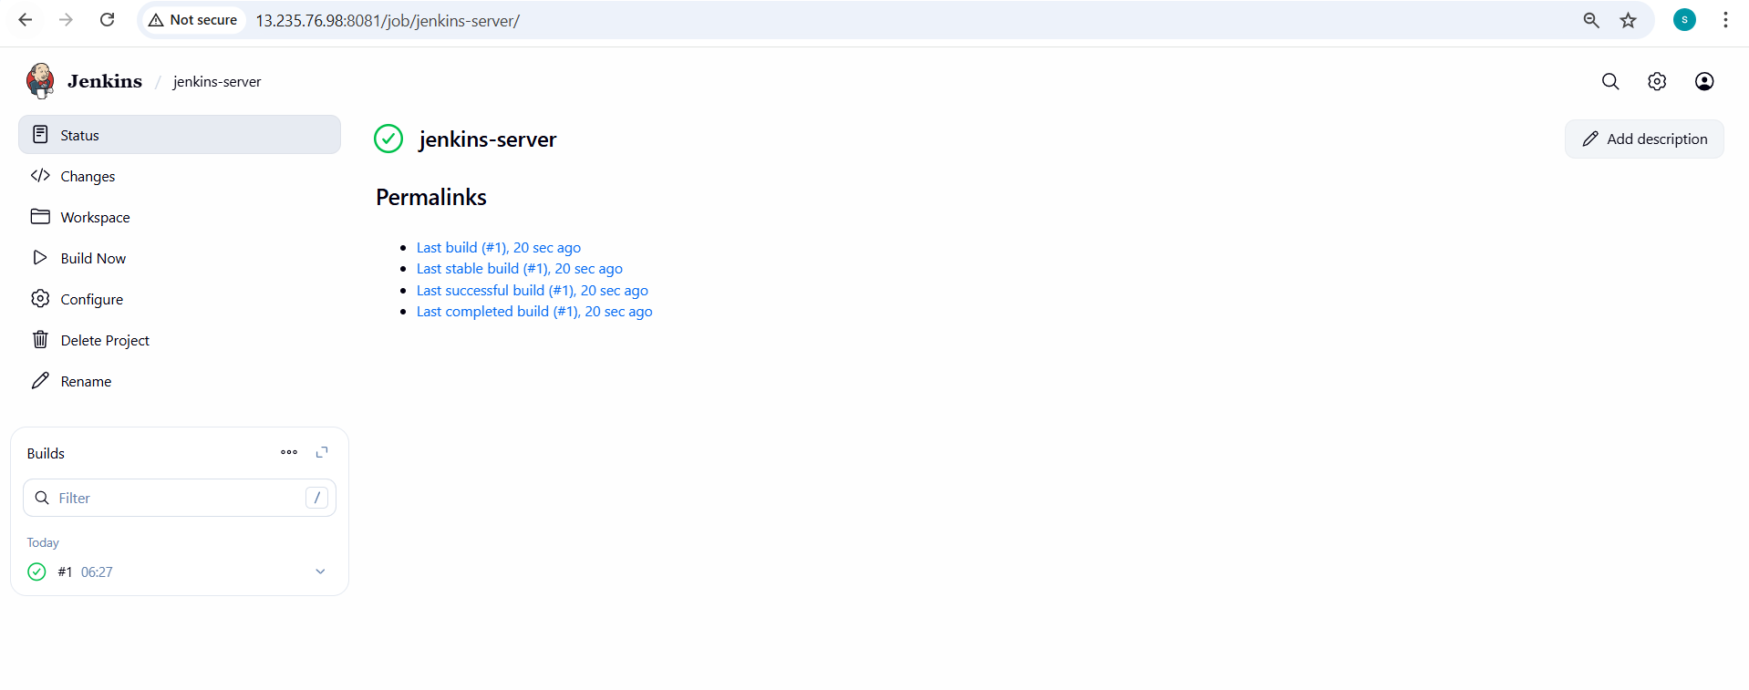
SonarQube Integration :to check the quality of the code
Go to the sonarqube server and run the sonar
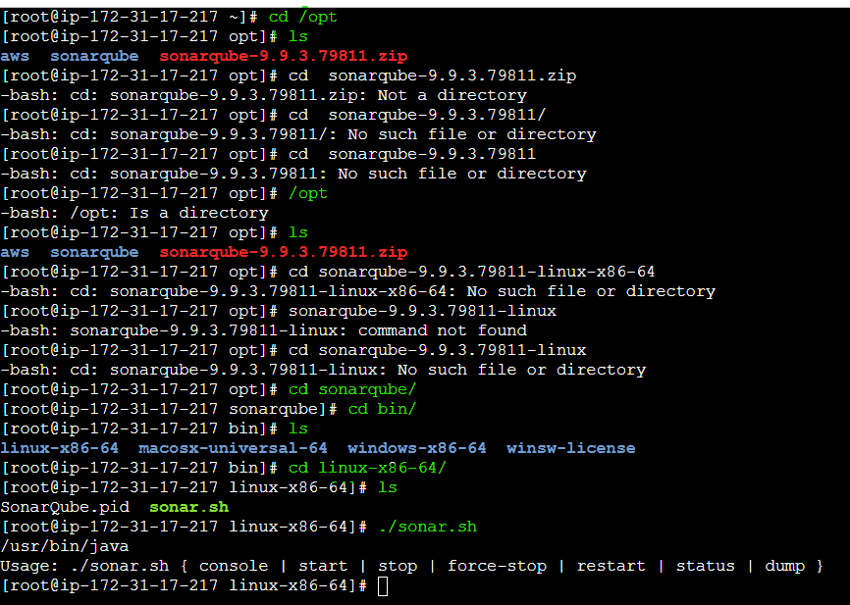
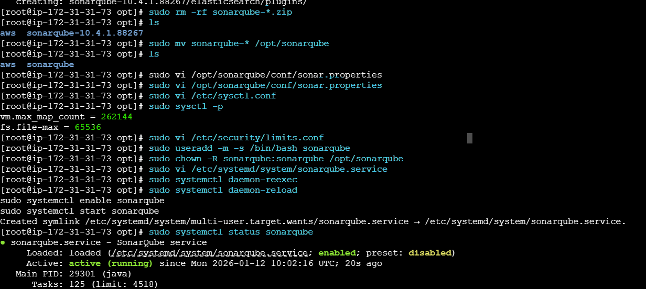

- Go to the browser and
- Browse the ip with 9000
- Successfully sonar is running

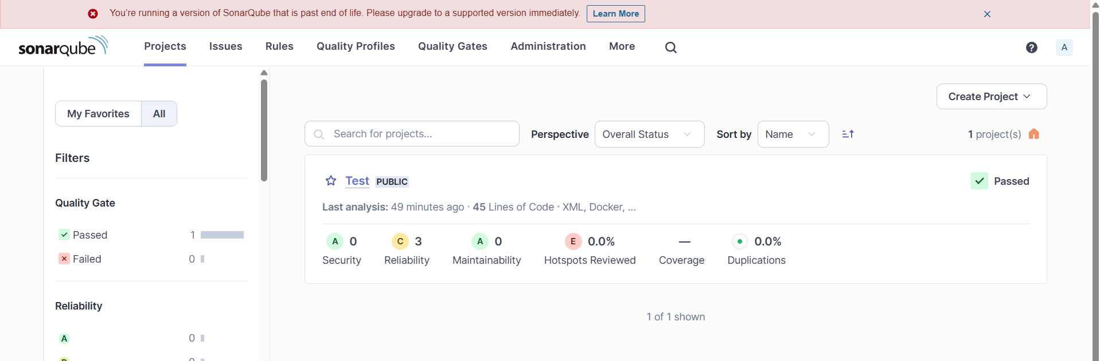
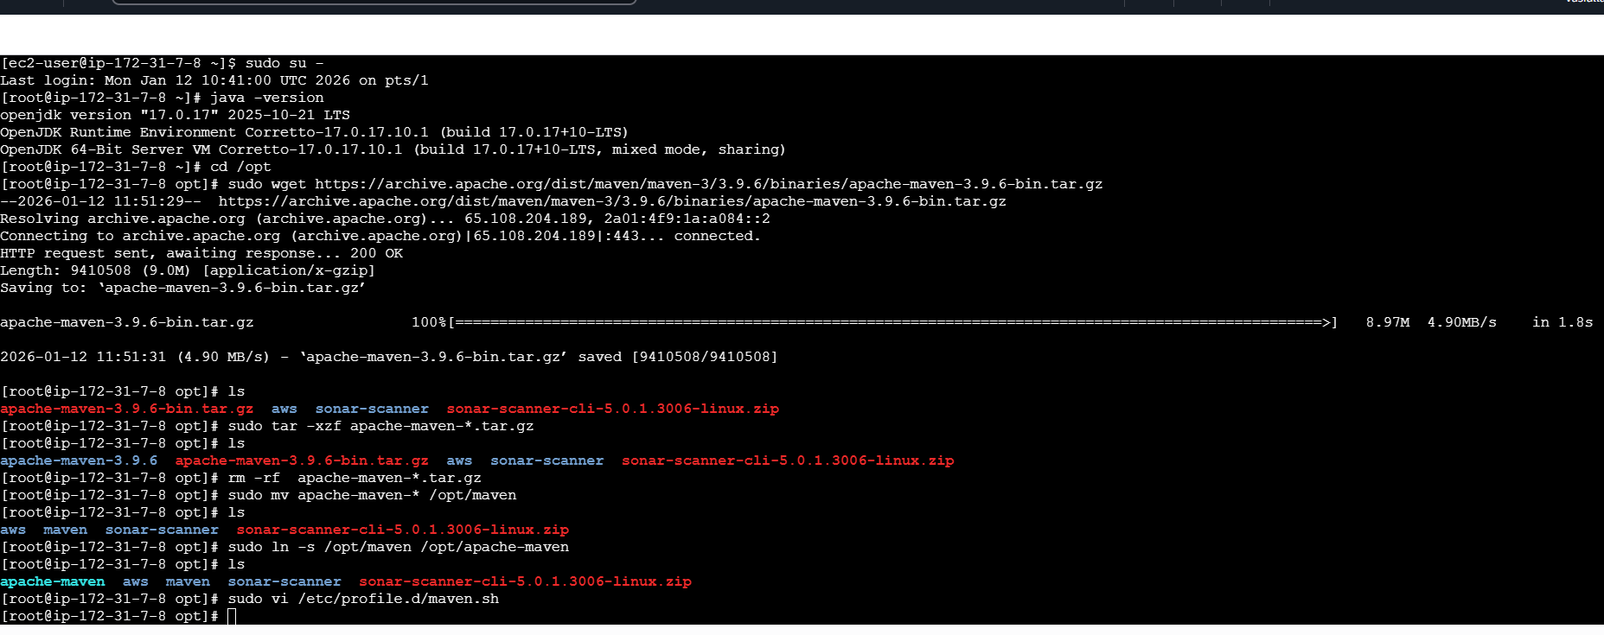
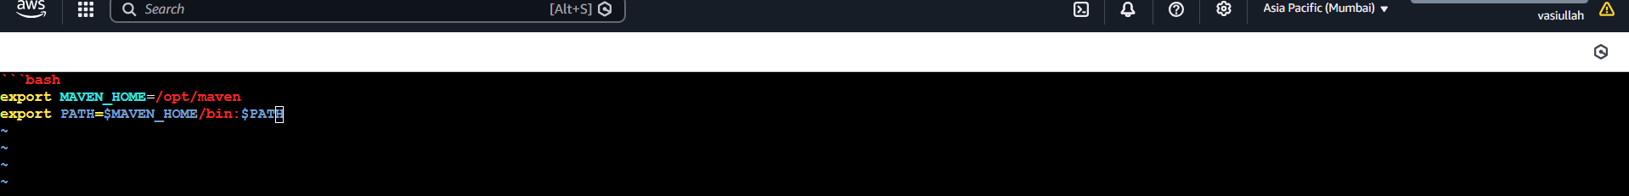
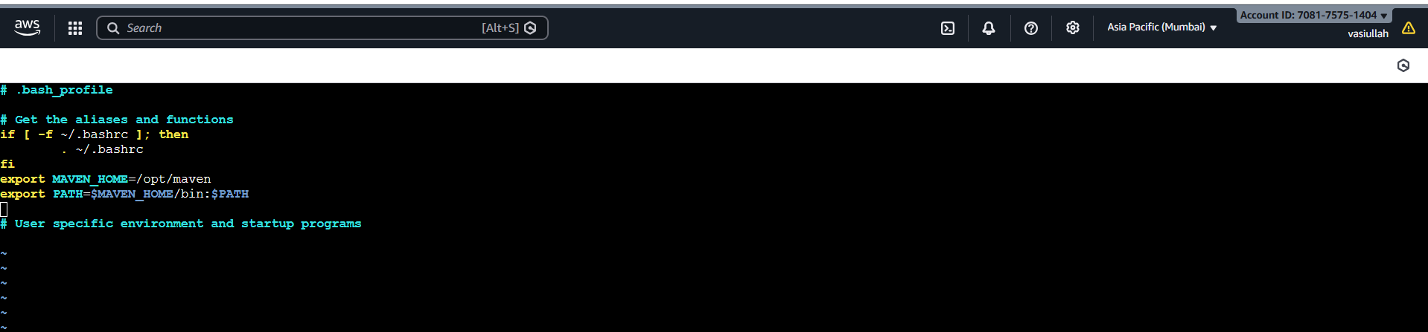
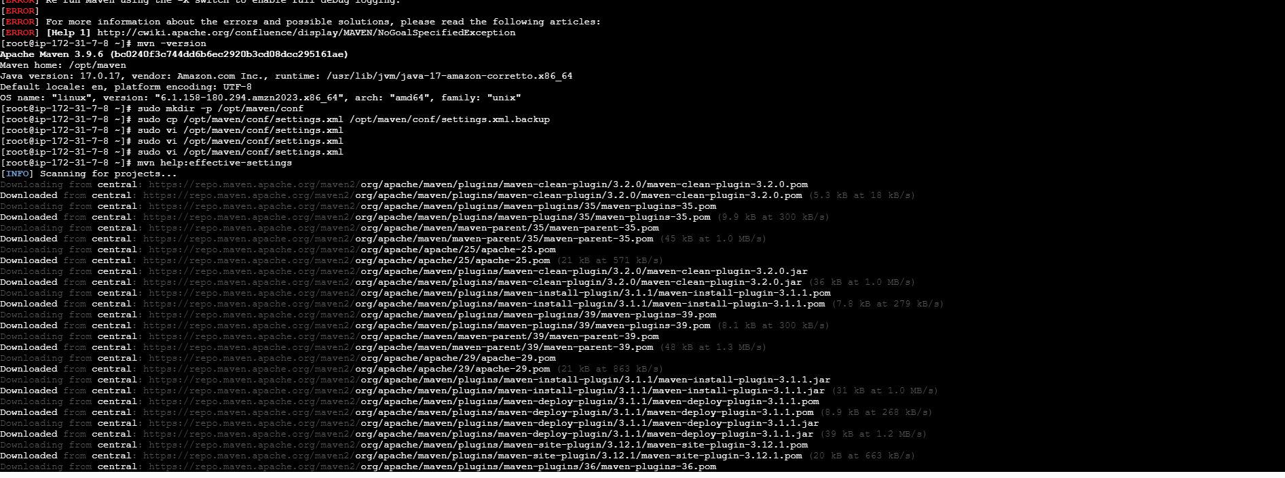
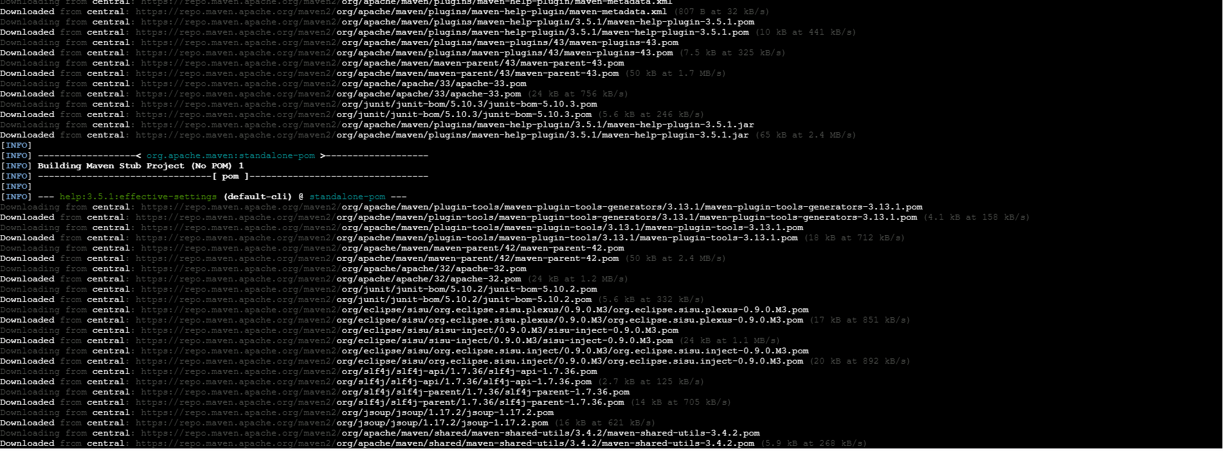
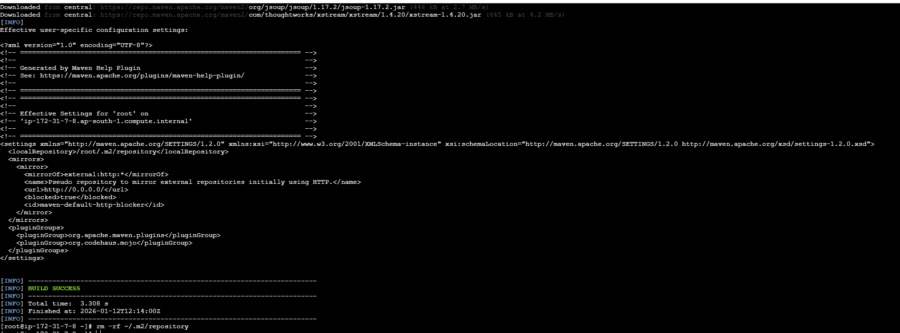

Nexus:
- Create Nexus-ec2 with t2.large
- yum install -y java-17-amazon-corretto

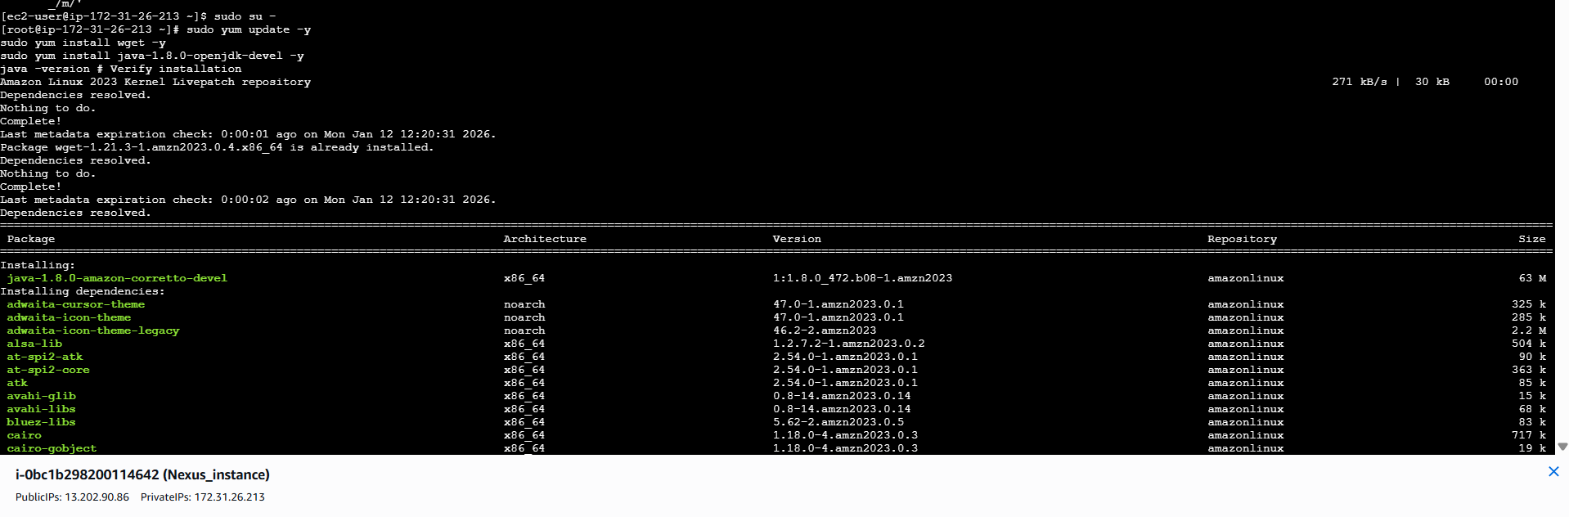
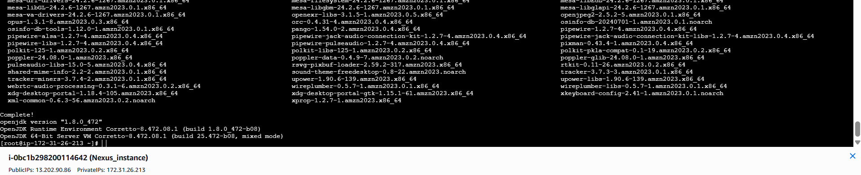
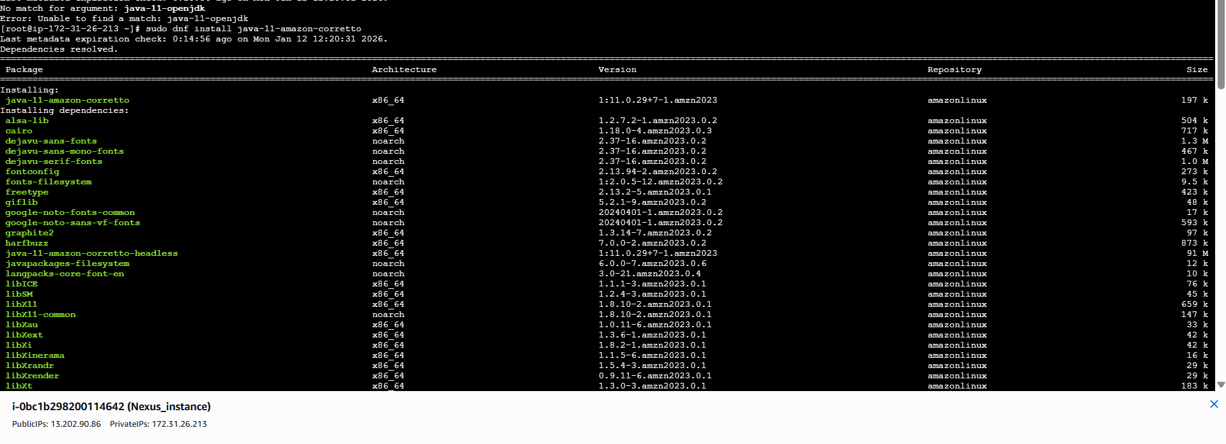
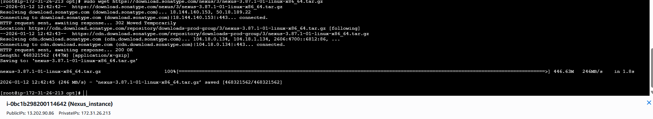
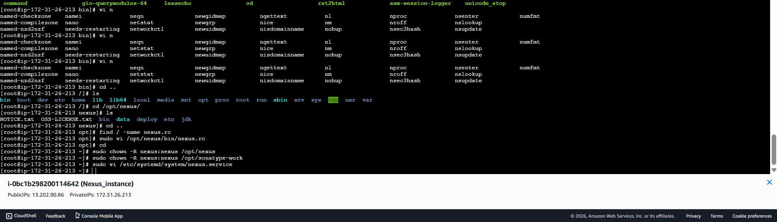
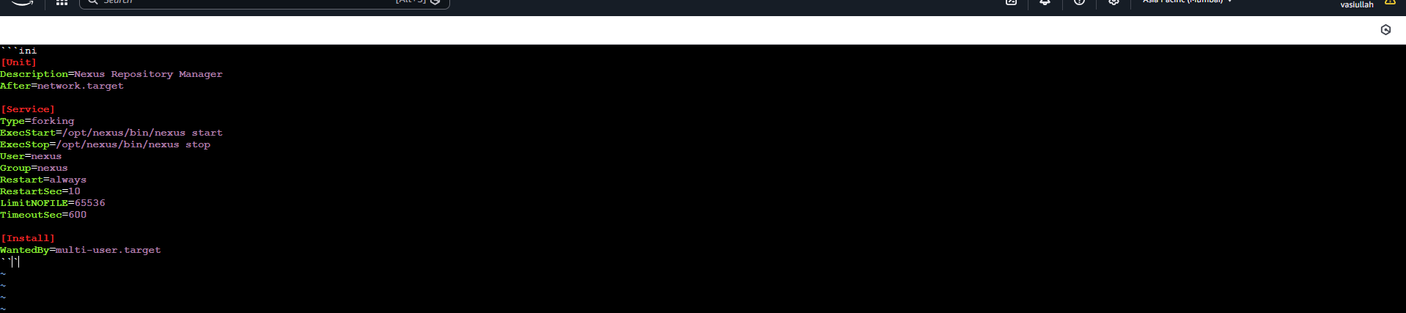
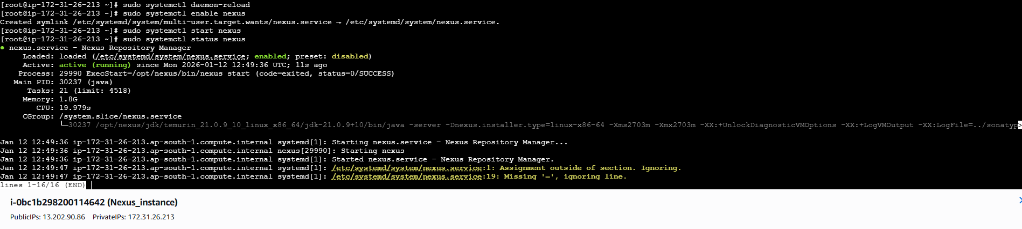

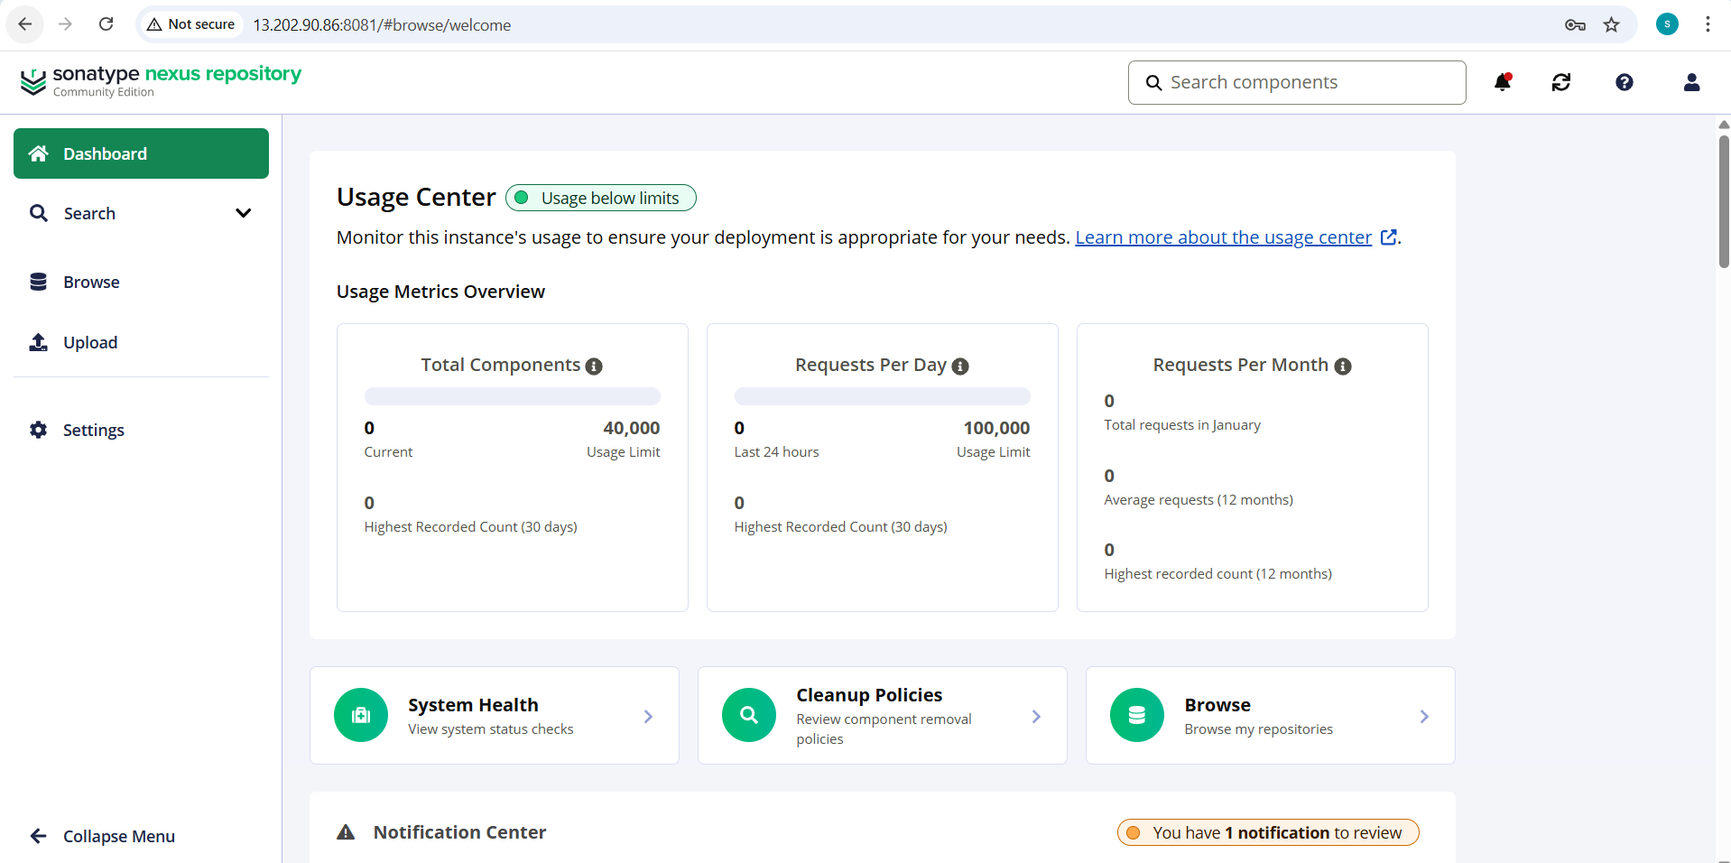

- Now we need to integrate Jenkins with nexus in UI level
- Install Nexus Plugin
- Goto manage Jenkins à plugins à available plugins à <Nexus Artifact Uploader>

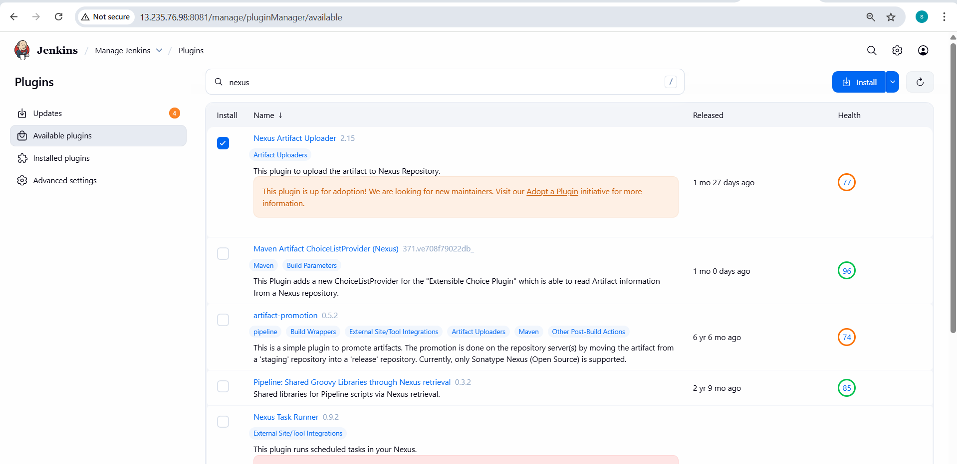
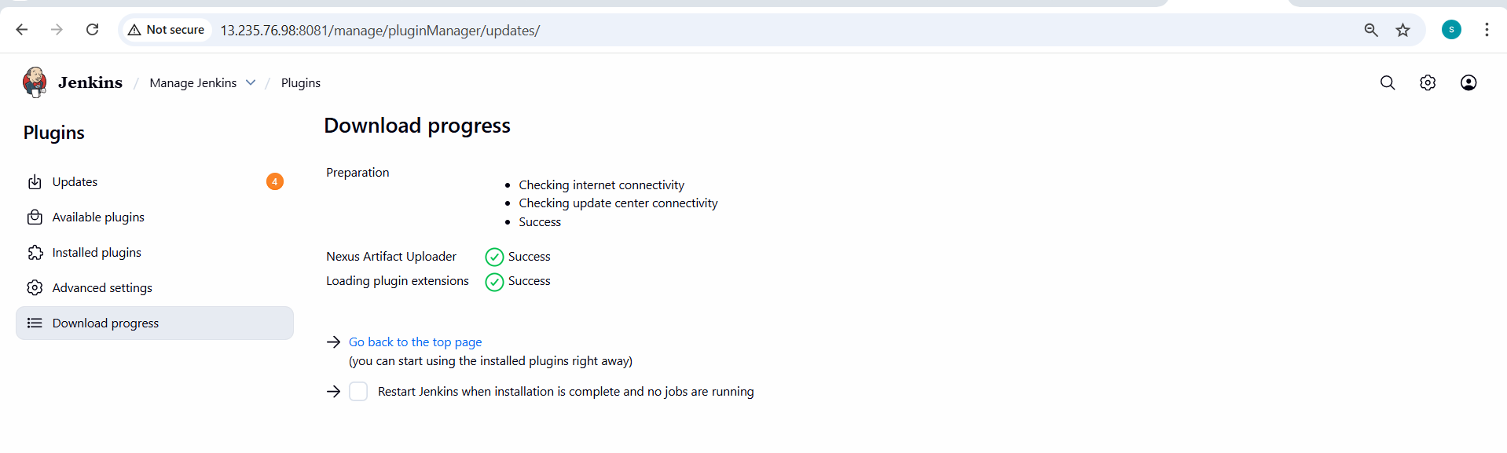
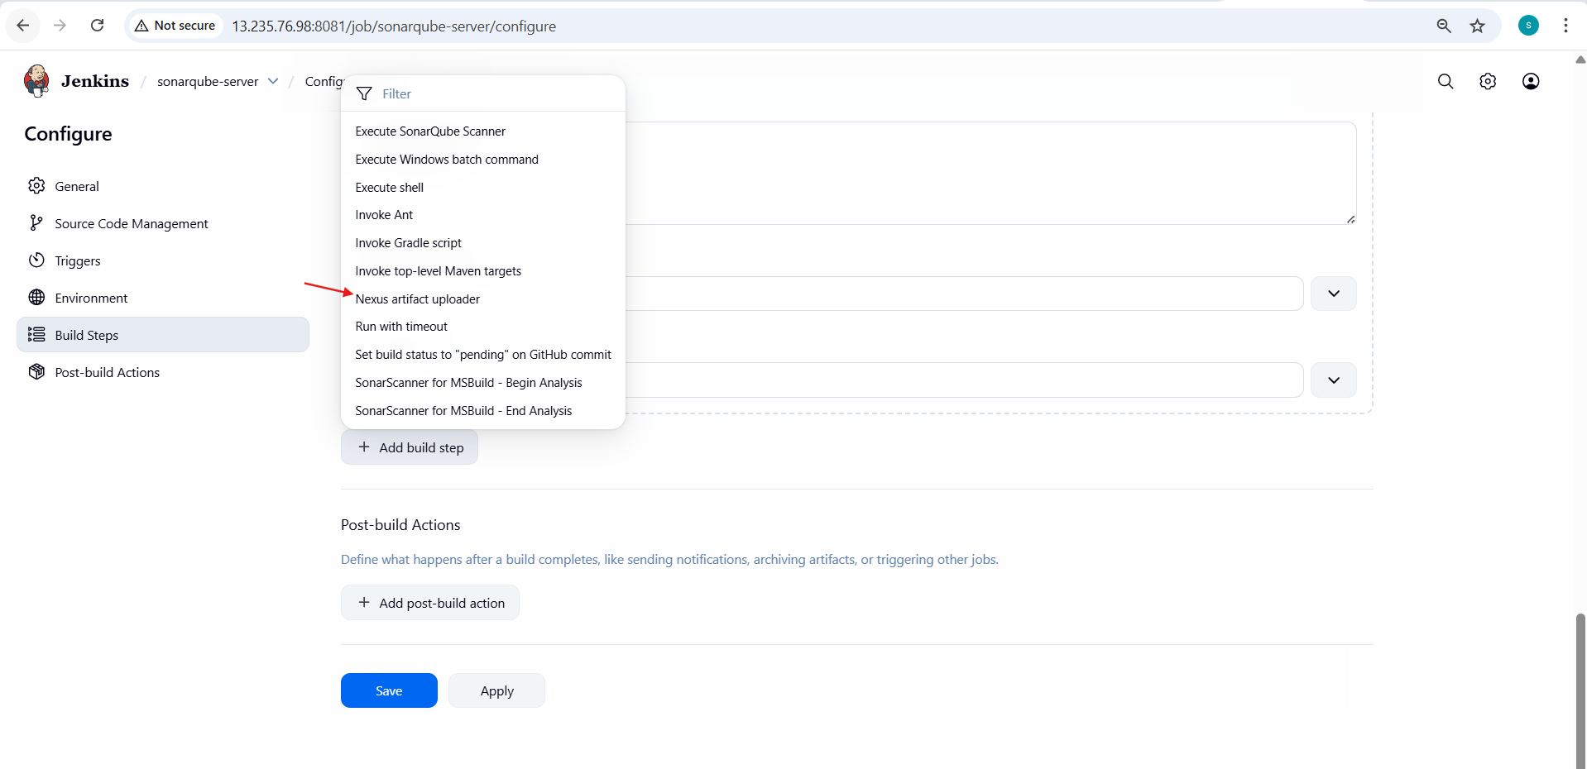
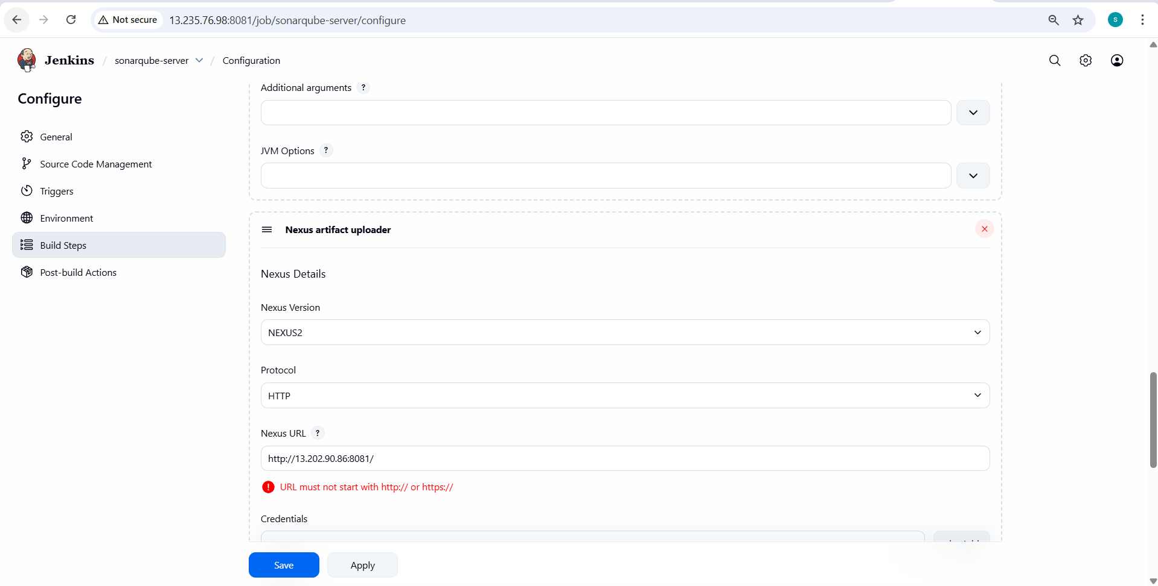

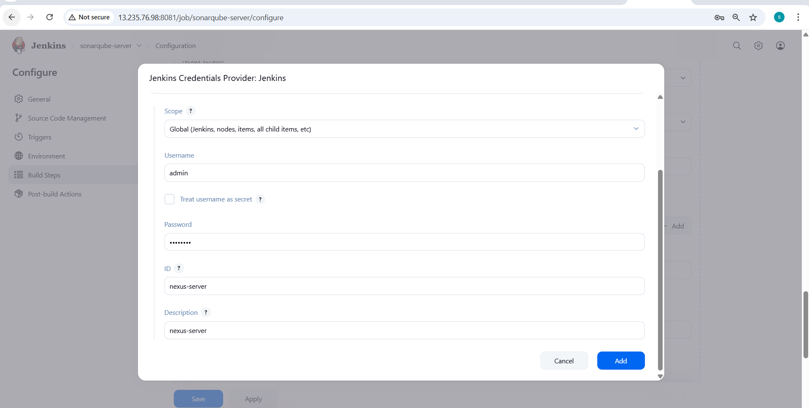
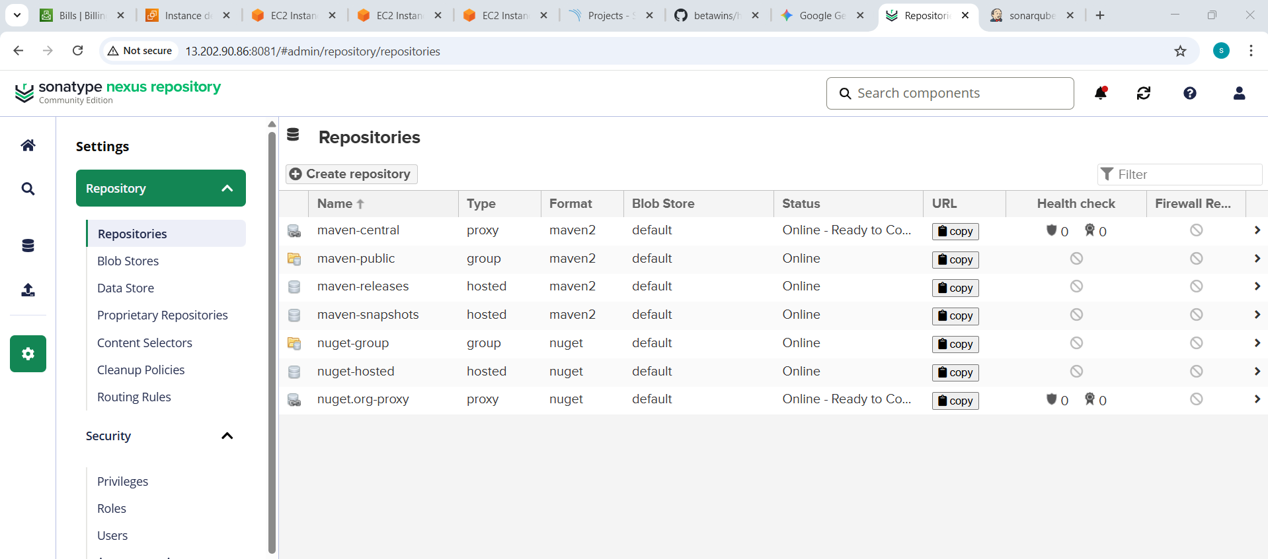
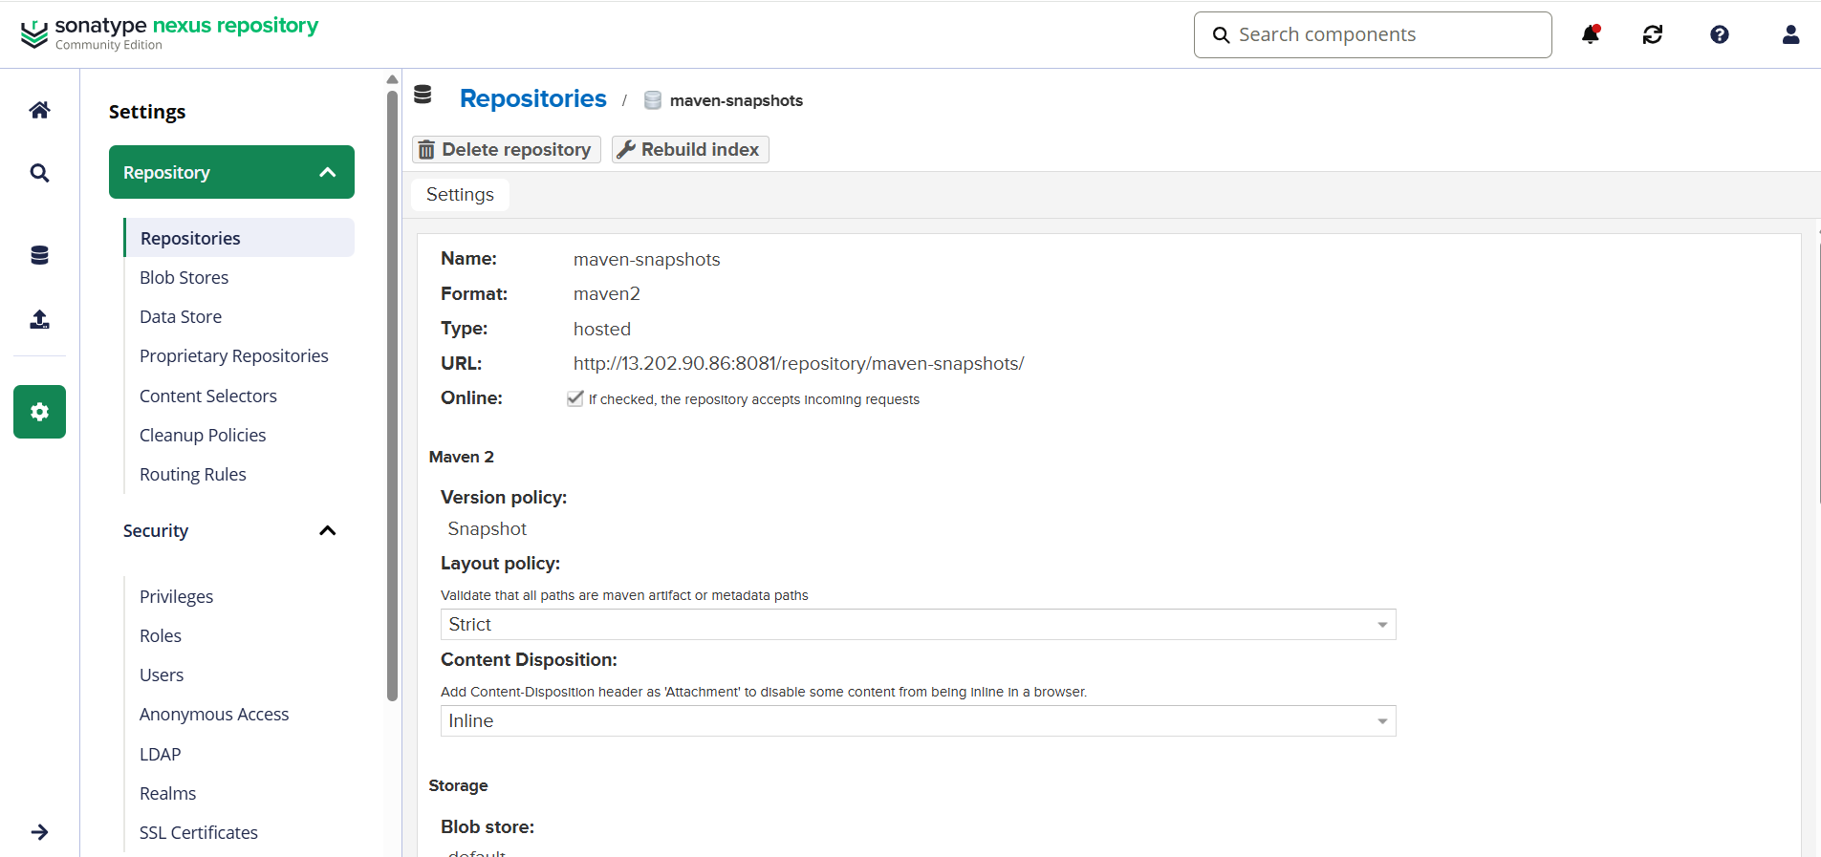
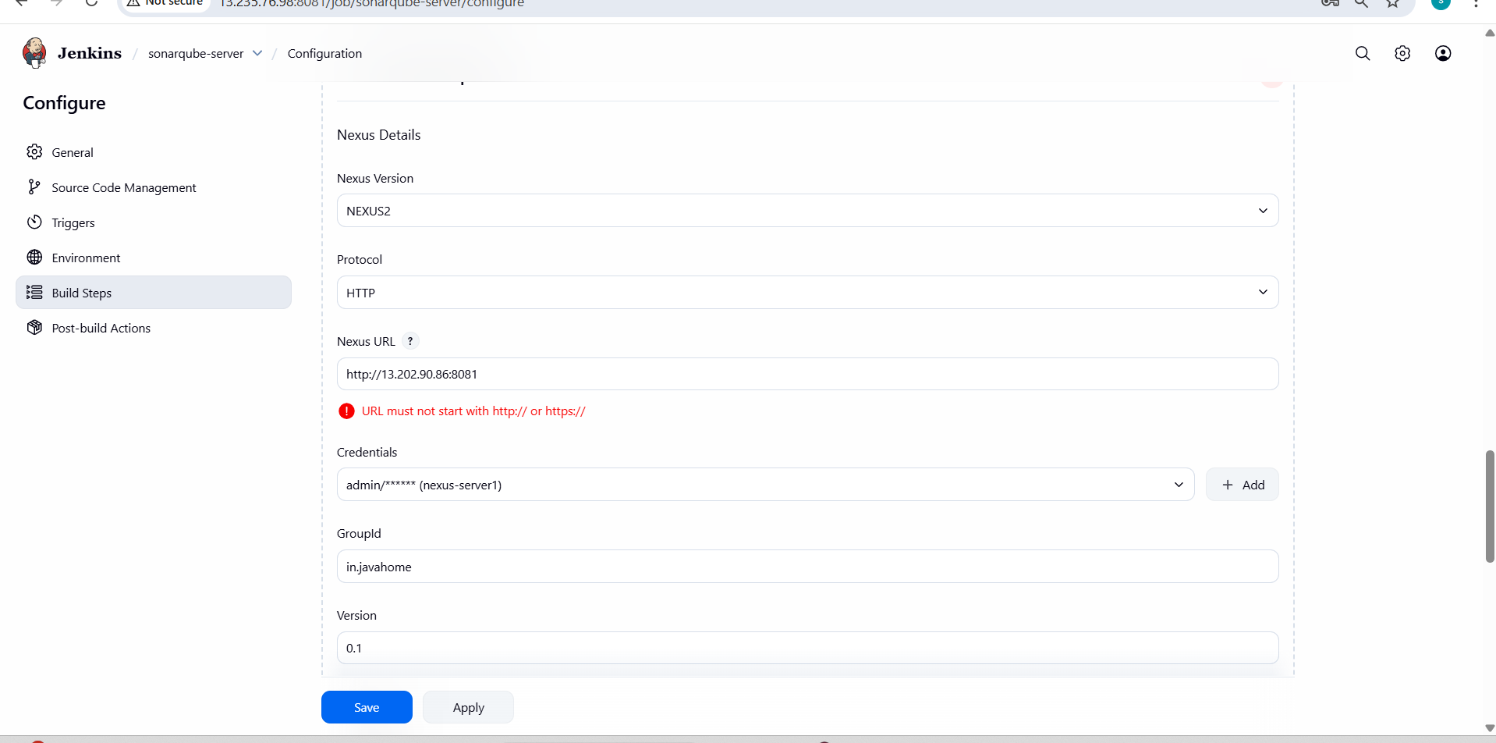
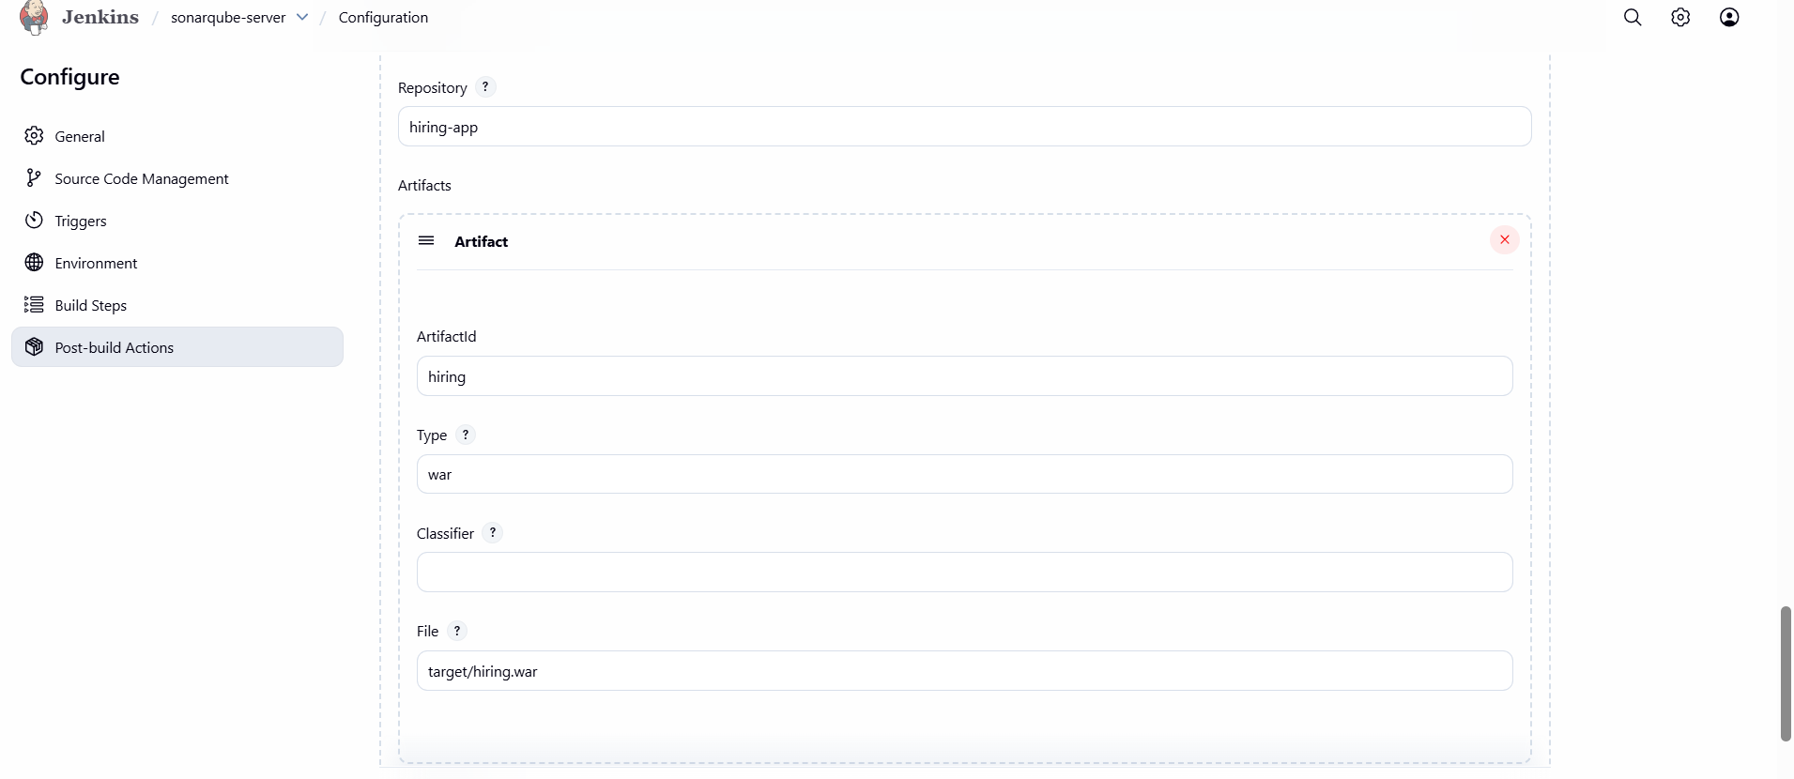
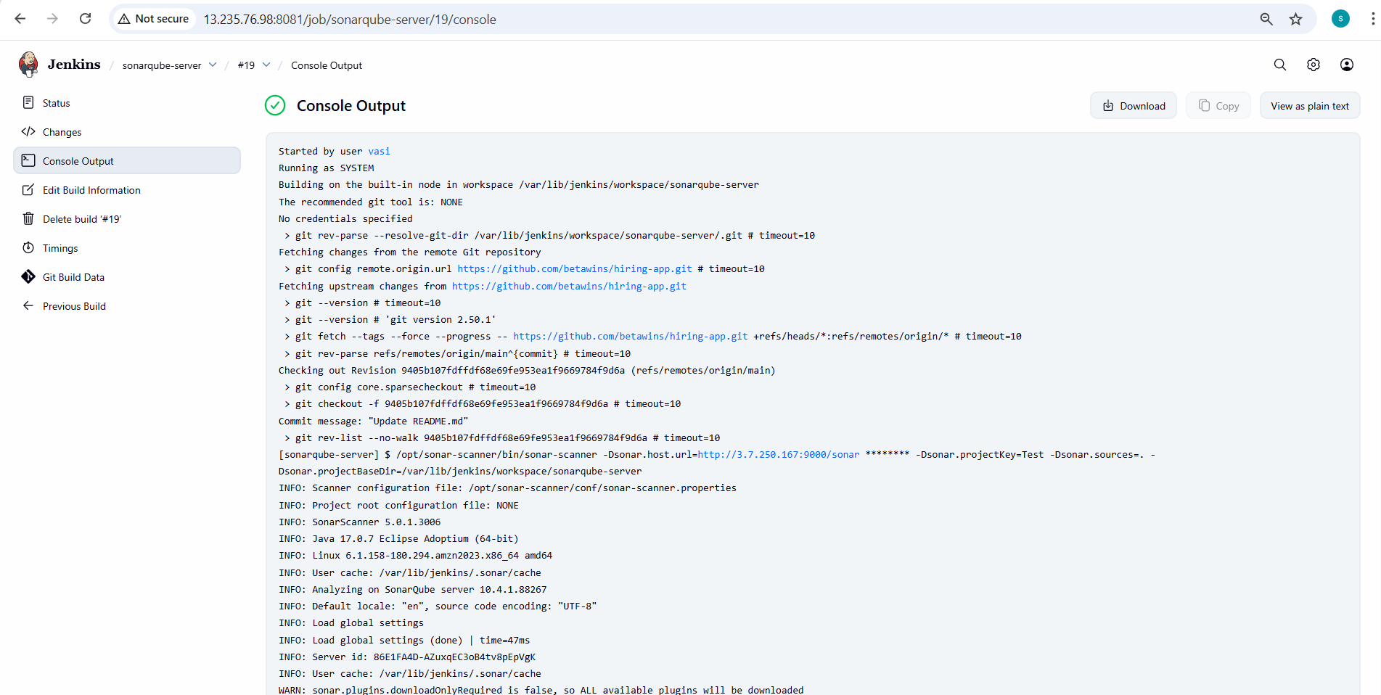
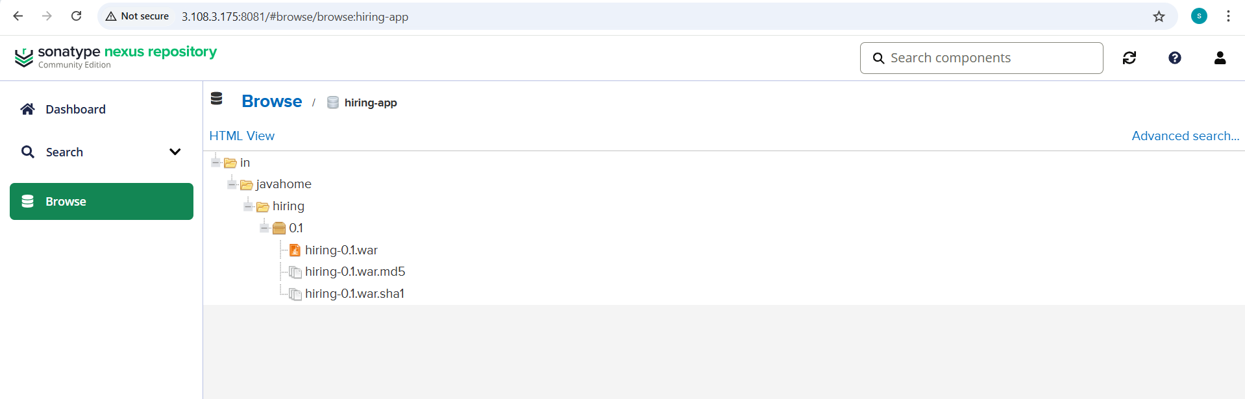
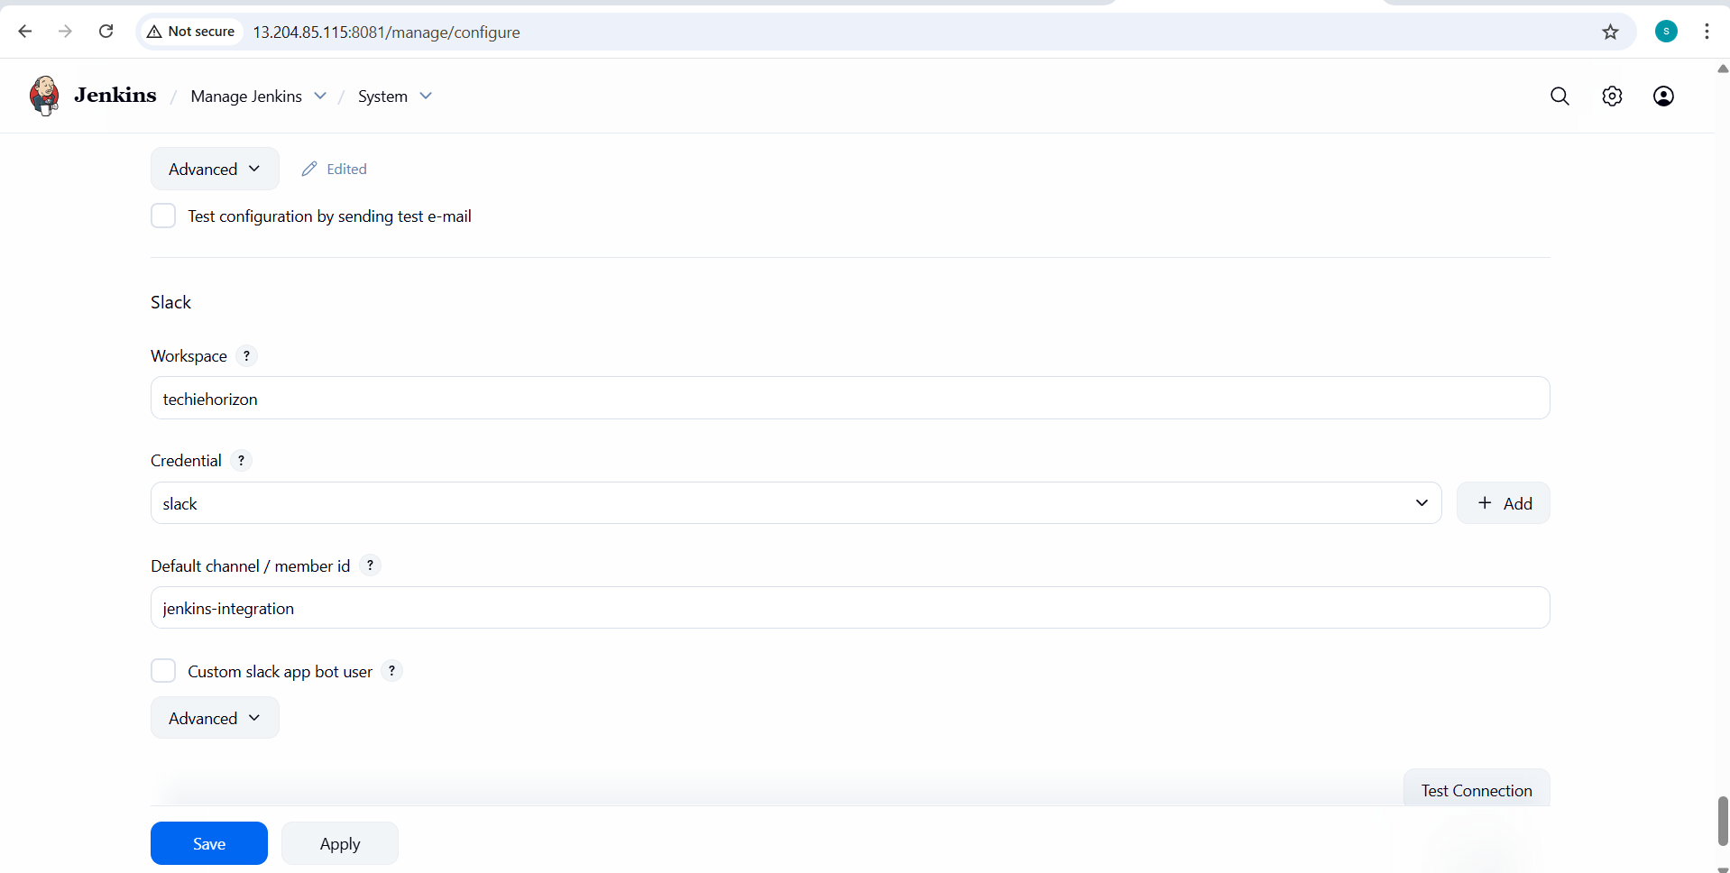
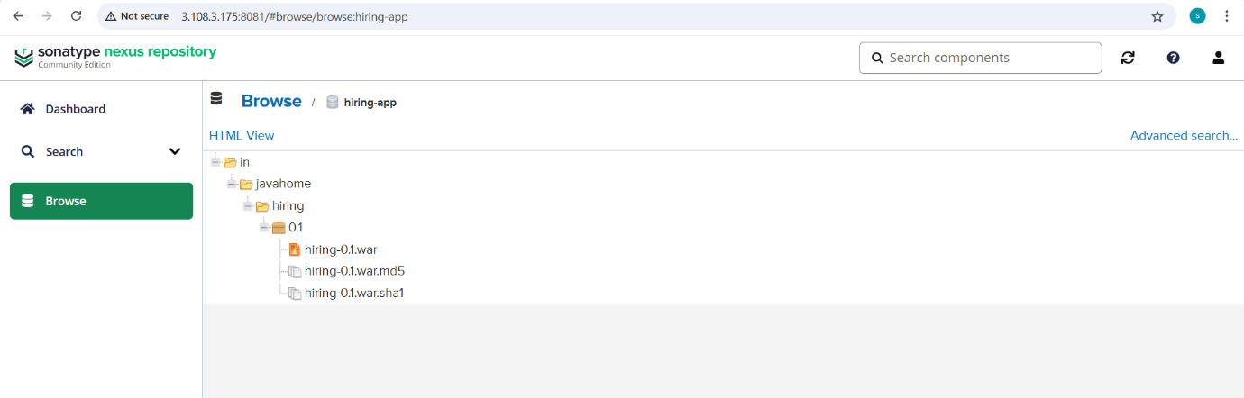

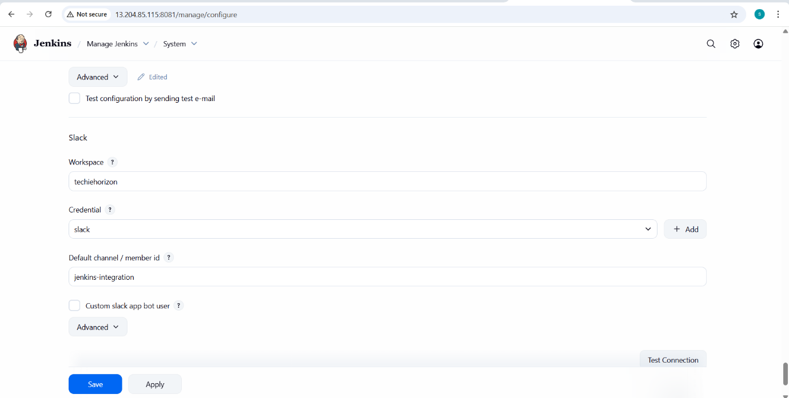

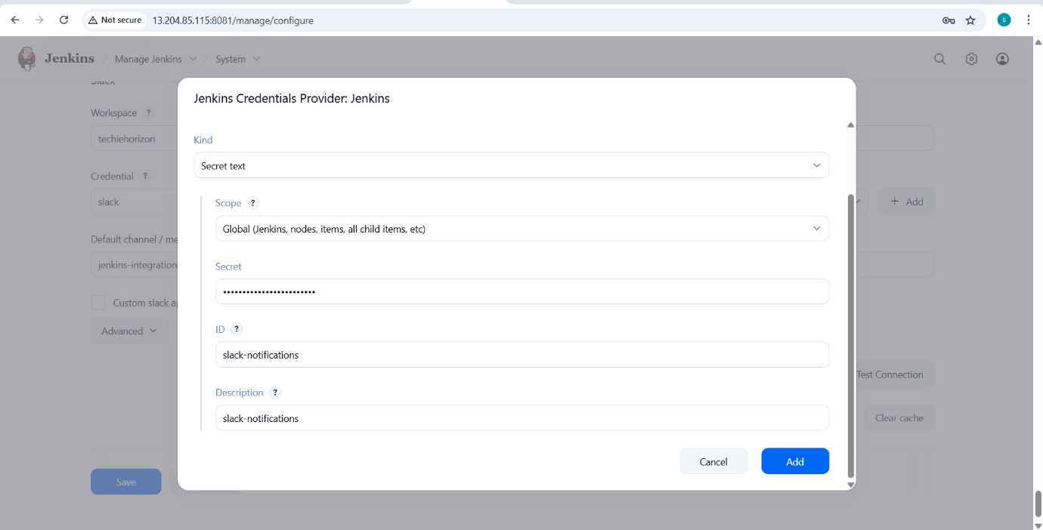

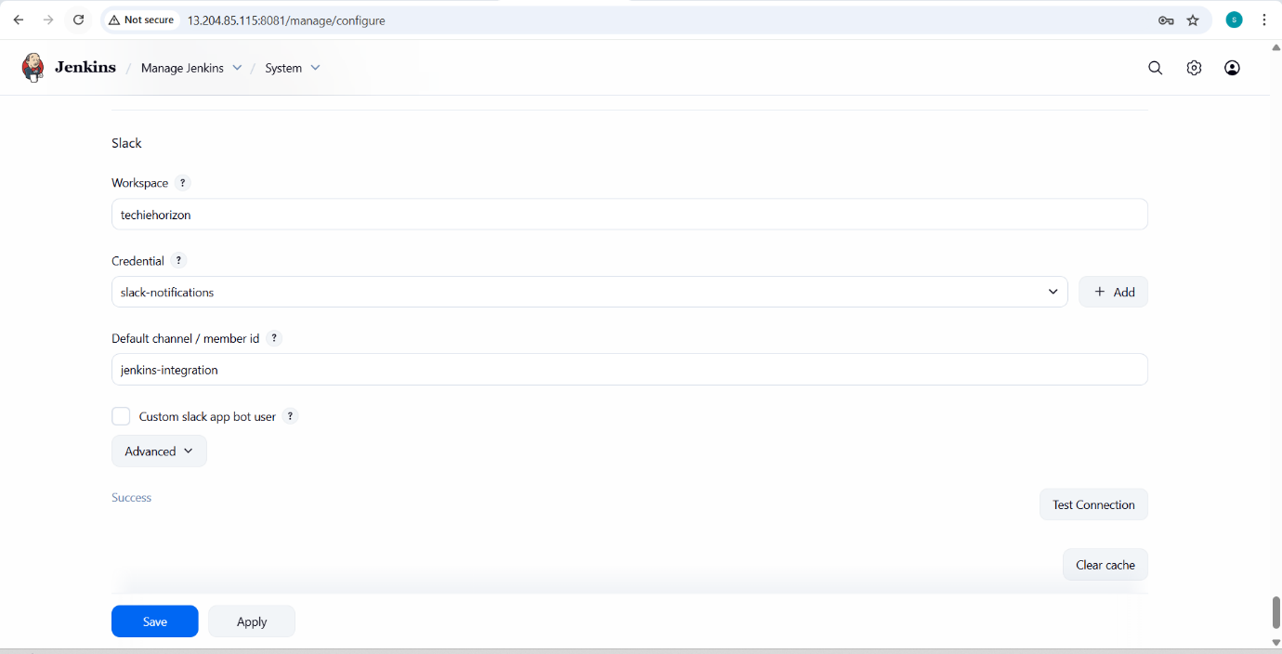

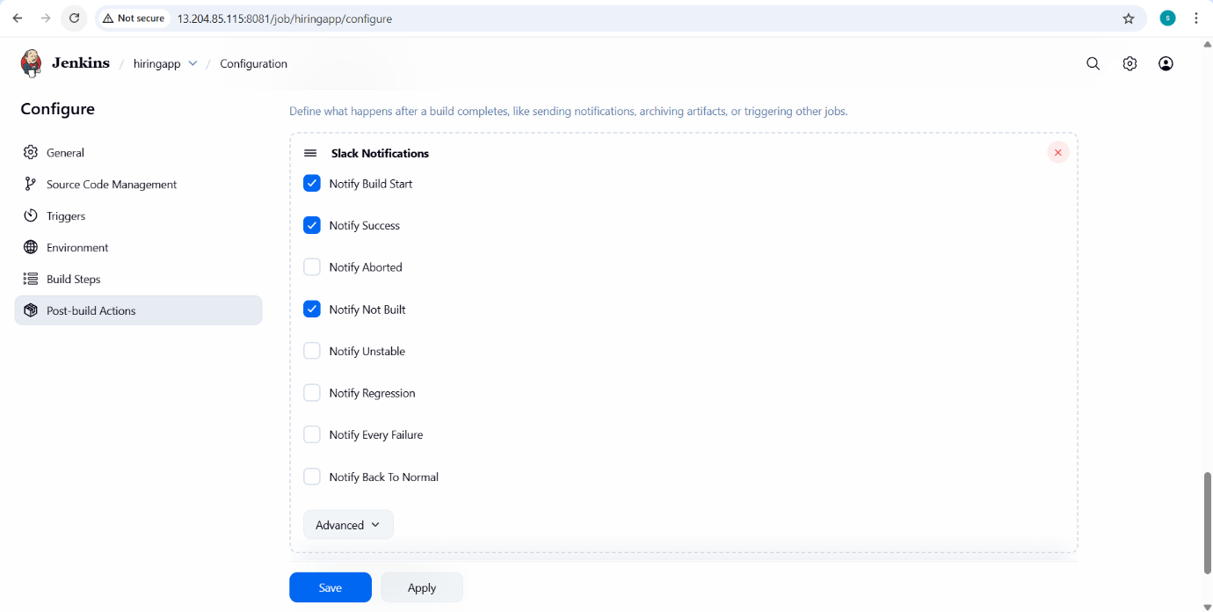

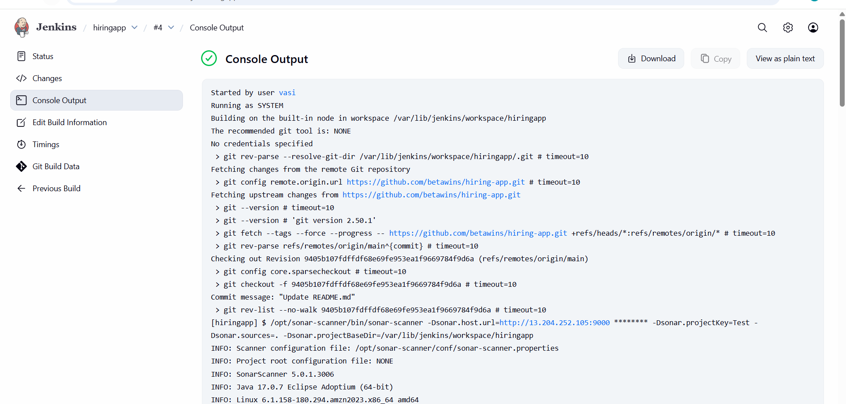

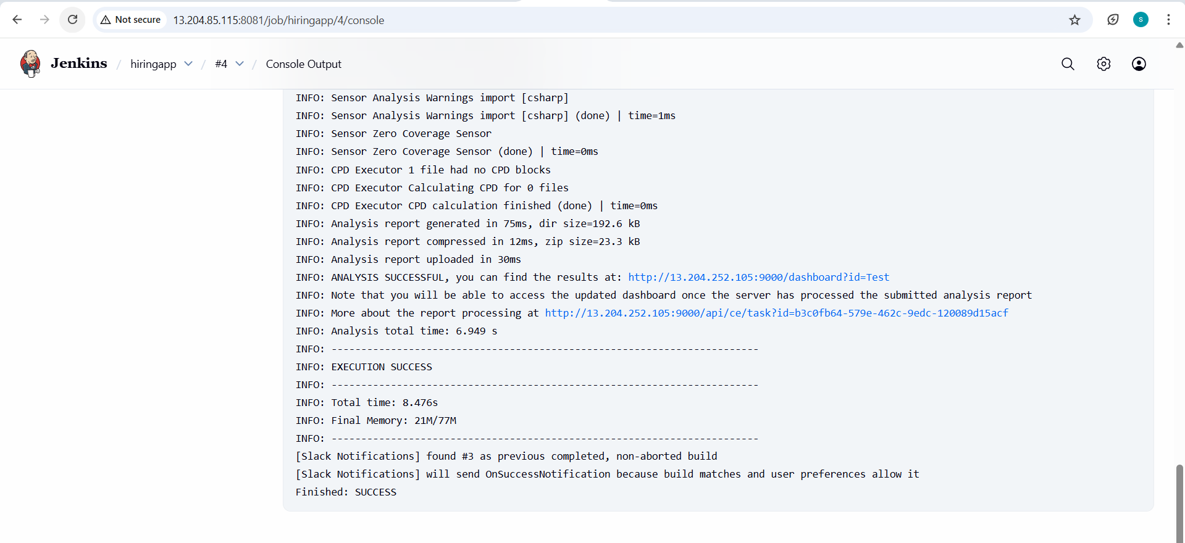

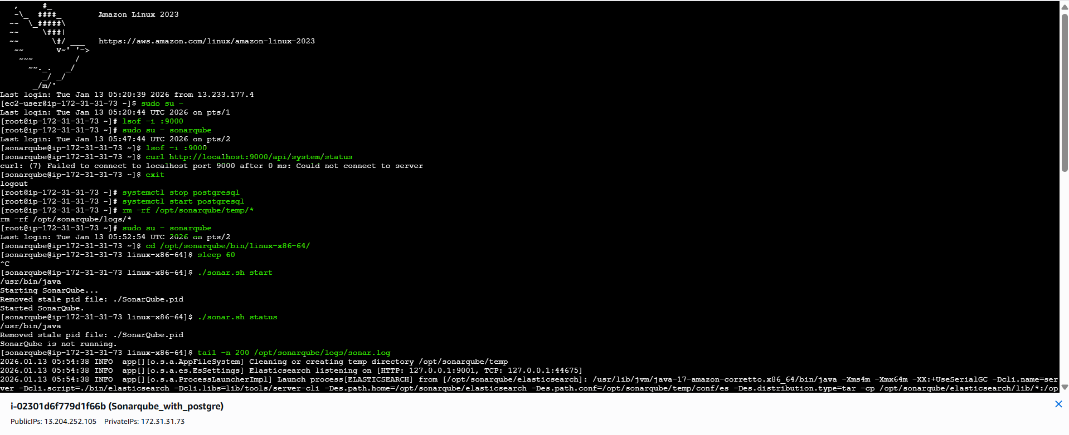
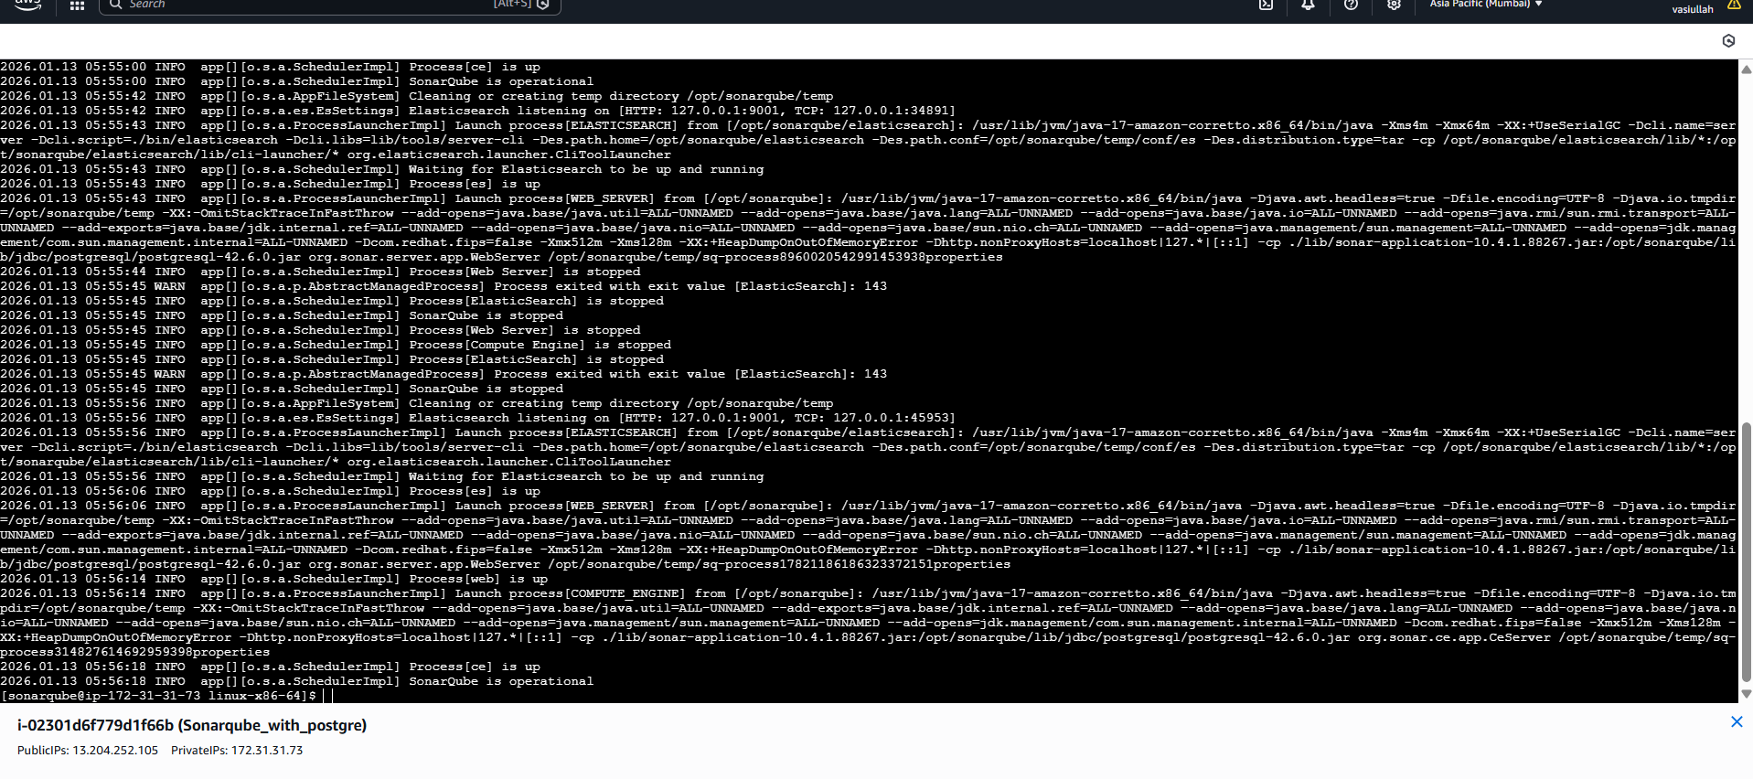
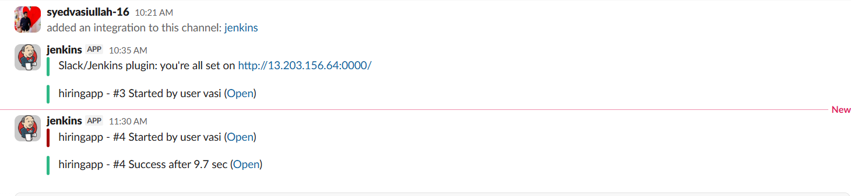

- Deploy On tomcat
- Goto Jenkins GUI page Manage Jenkins Available Plugins <Deploy to container>
- Now Launch a new ec2 instance for tomcat deployment
- Tomcat-ec2 <t2.micro>
- Install java and install tomcat in it and start
- Install java yum install -y java-17-amazon-corretto

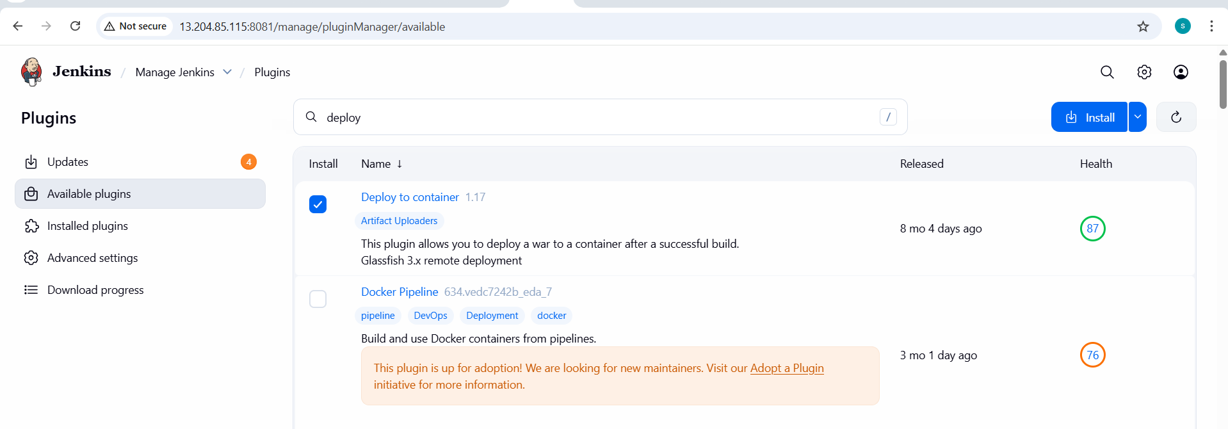
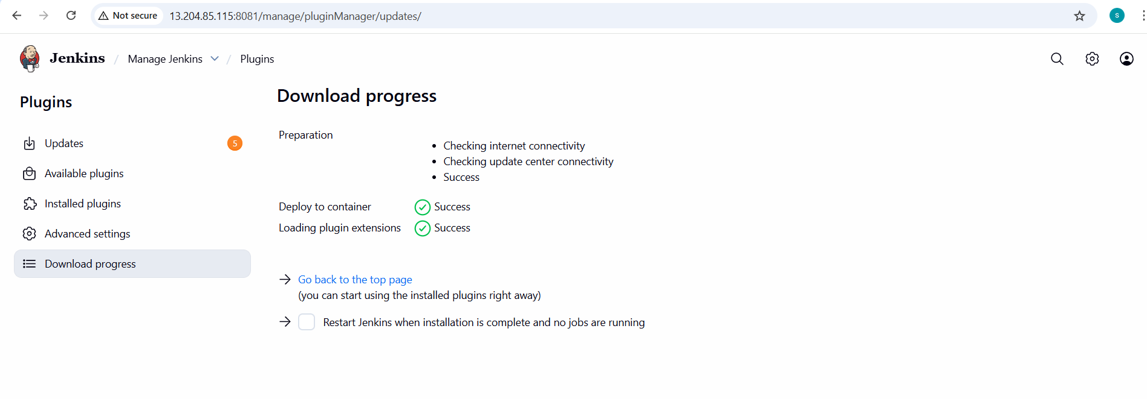

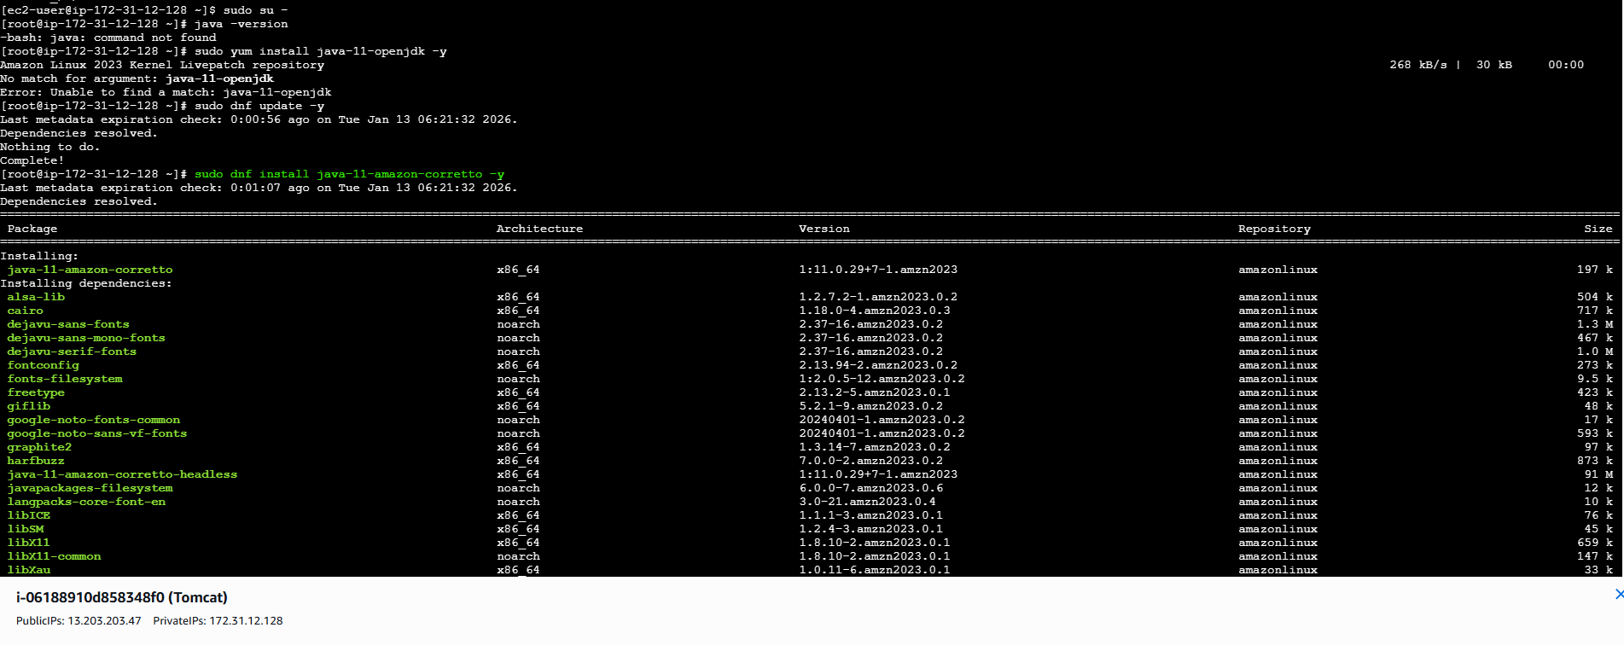
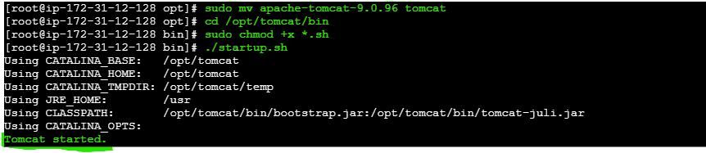
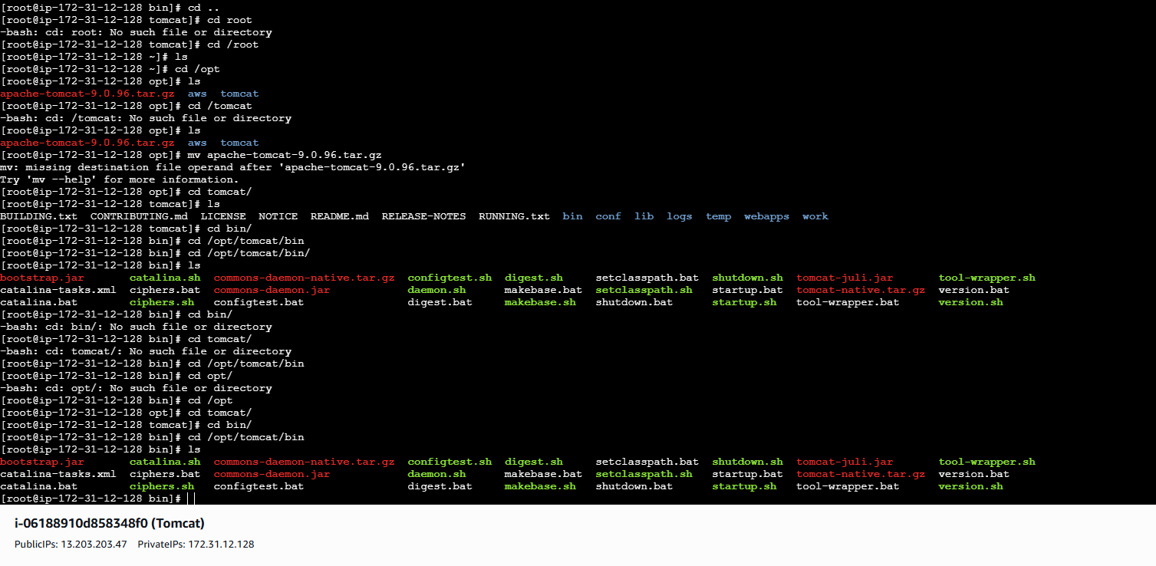

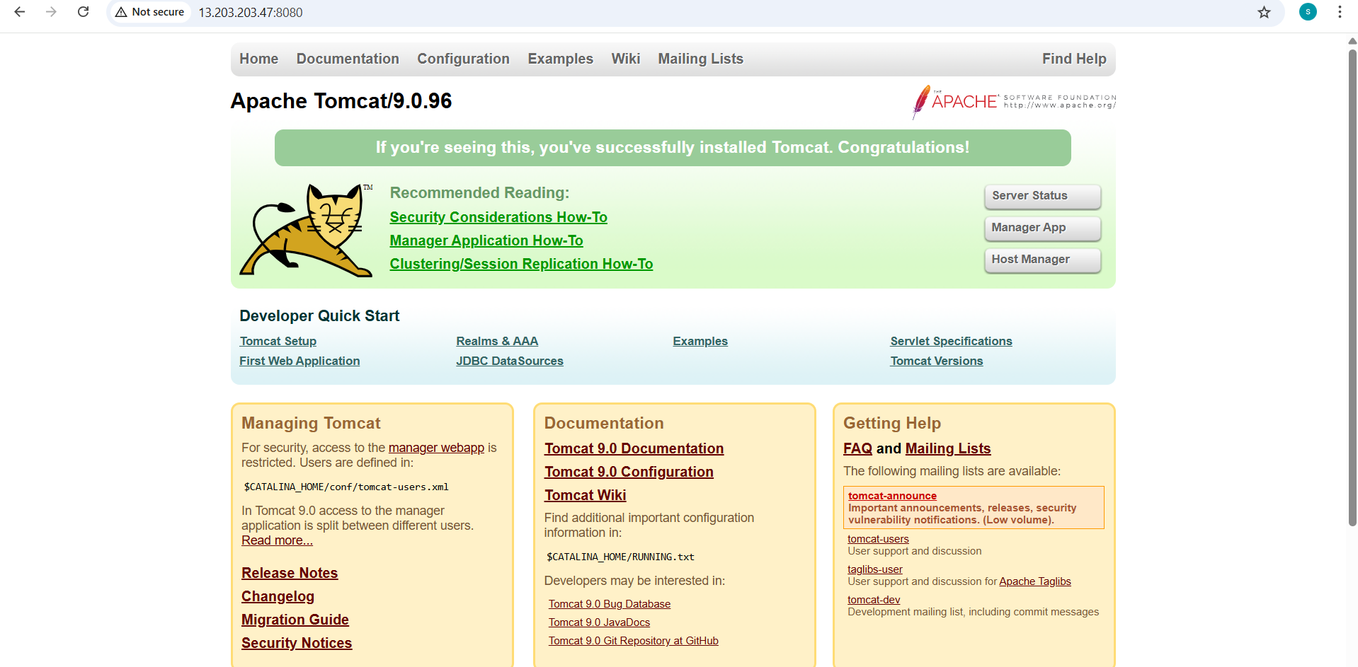

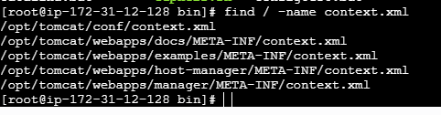

vi /opt/tomcat/webapps/docs/META-INF/context.xml
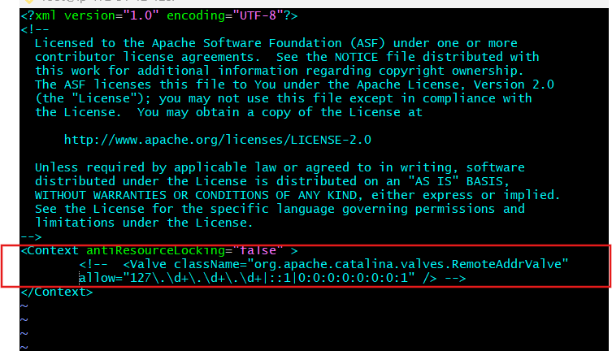

vi /opt/tomcat/webapps/examples/META-INF/context.xml
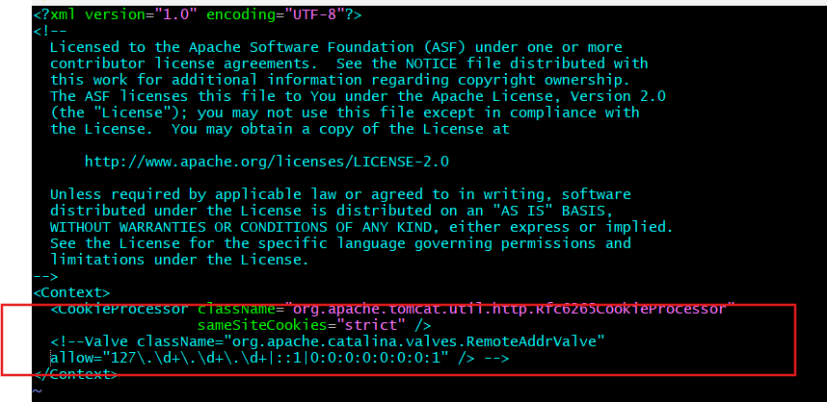
vi /opt/tomcat/webapps/host-manager/META-INF/context.xml
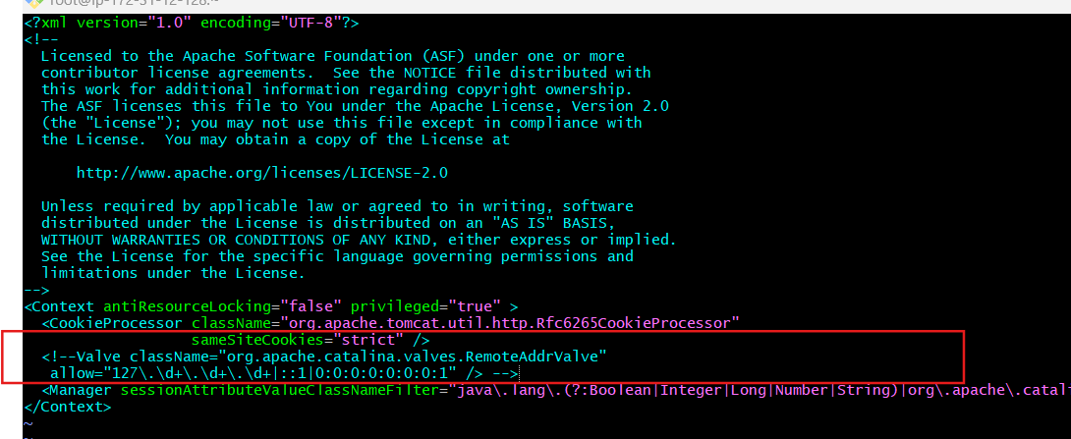
vi /opt/tomcat/webapps/manager/META-INF/context.xml
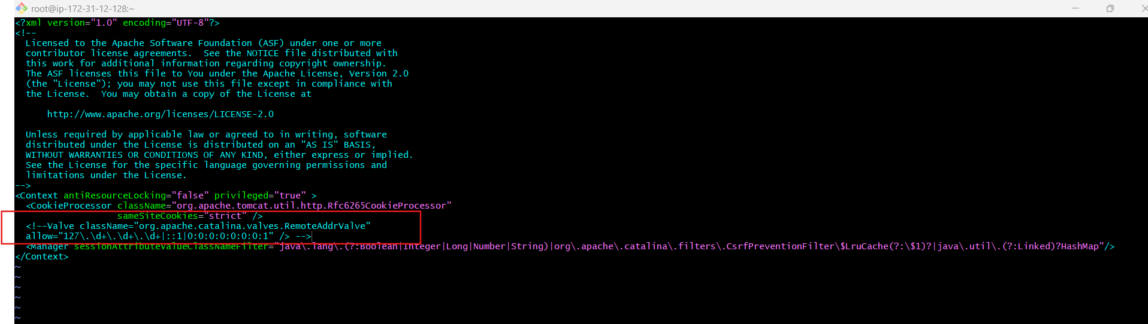
- Now go to conf in xml file and add the below details to add user to tomcat <tomcat-user.xml>
- cd /opt/tomcat/conf/
- vi tomcat-users.xml
- <role rolename="manager-gui"/>
- <role rolename="manager-script"/>
- <role rolename="manager-jmx"/>
- <role rolename="manager-status"/>
- <user username="admin" password="admin" roles="manager-gui,manager-script,managerjmx,manager-status"/>
- <user username="deployer" password="deployer" roles="manager-script"/>
- <user username="tomcat" password="s3cret" roles="manager-gui"/>
- After adding user to tomcat we need to shutdown and then start the tomcat server

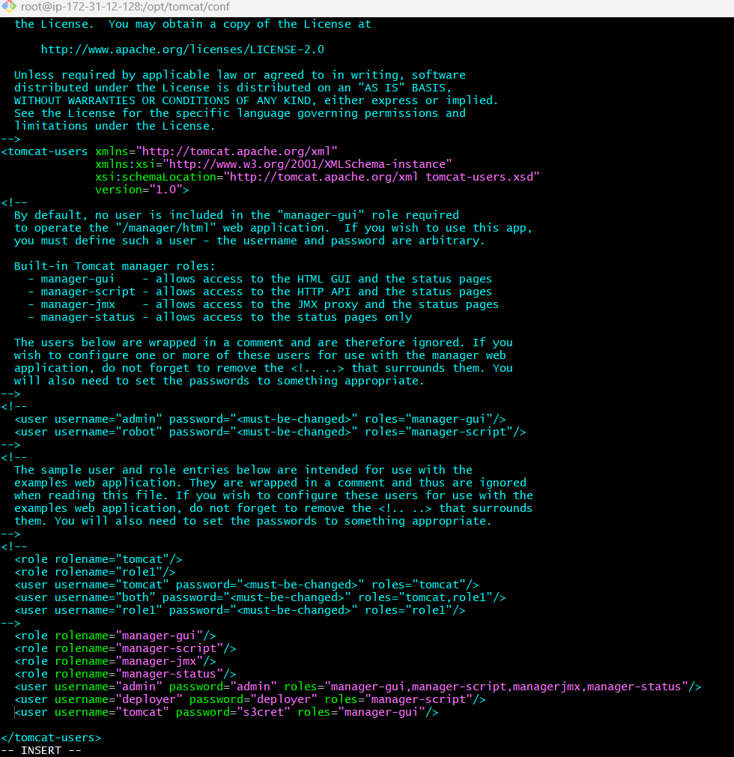
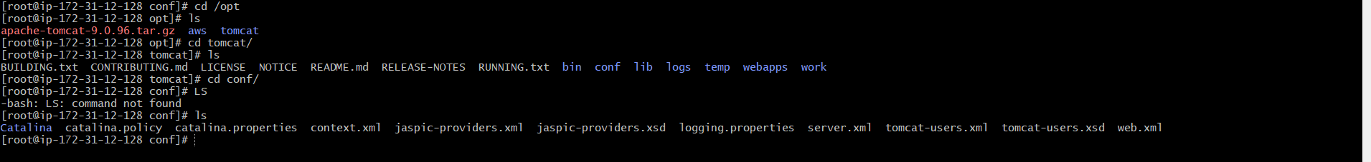
- Shutdown tomcat bash shutdown.sh
- Start tomcat bash startup.sh

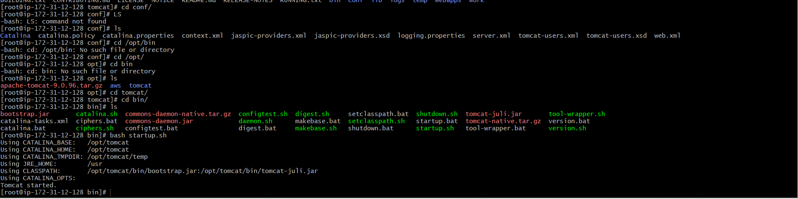
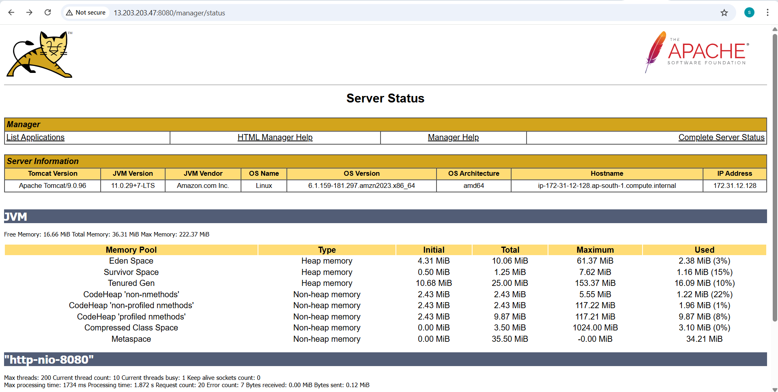
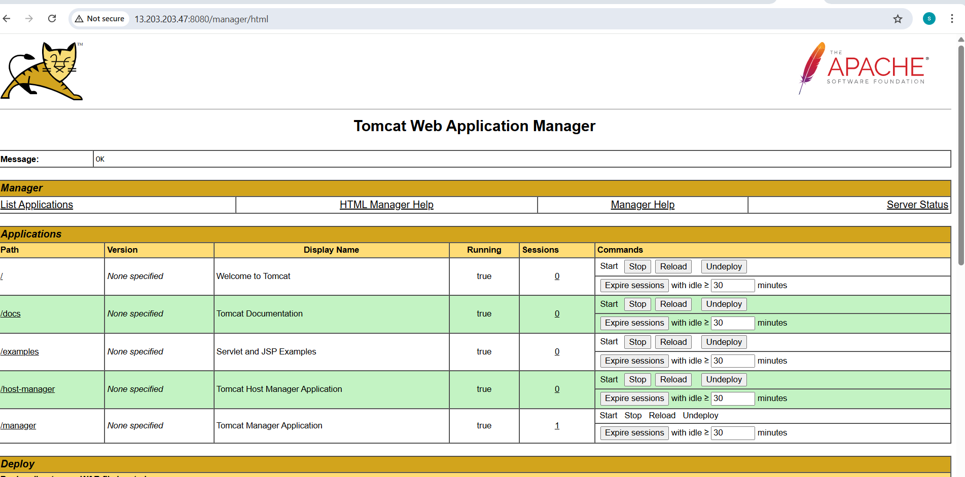

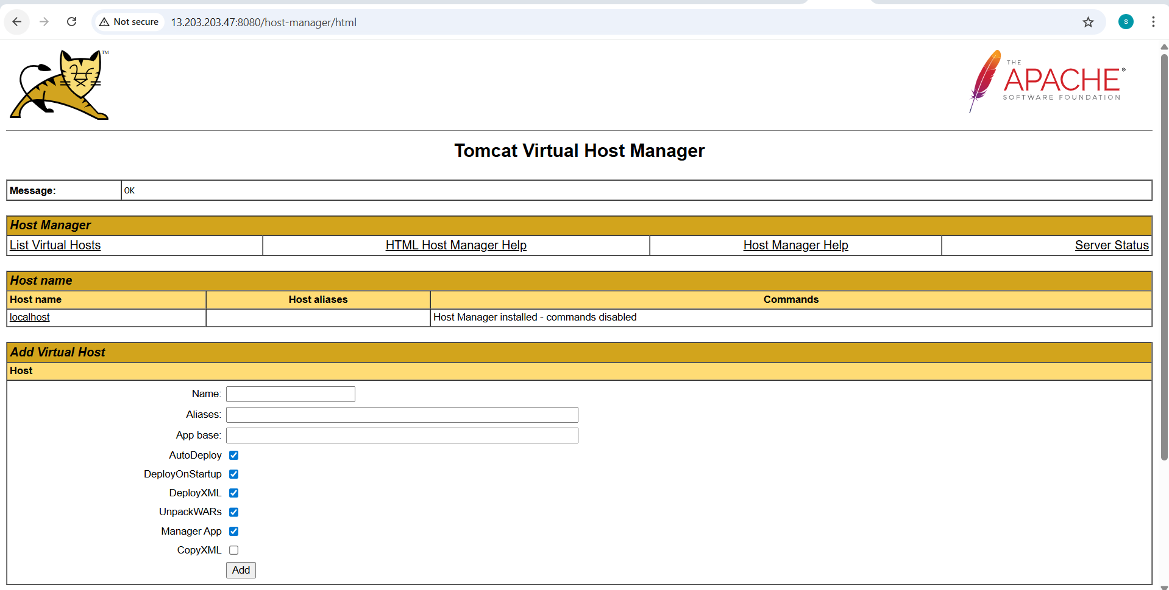
- Now just go to Jenkins GUI and add these crendentials and add WAR/EAR files as **/*.war
- Add the same credentials
- Goto Jenkins your job <hiring-app> configuration Post-build Actions

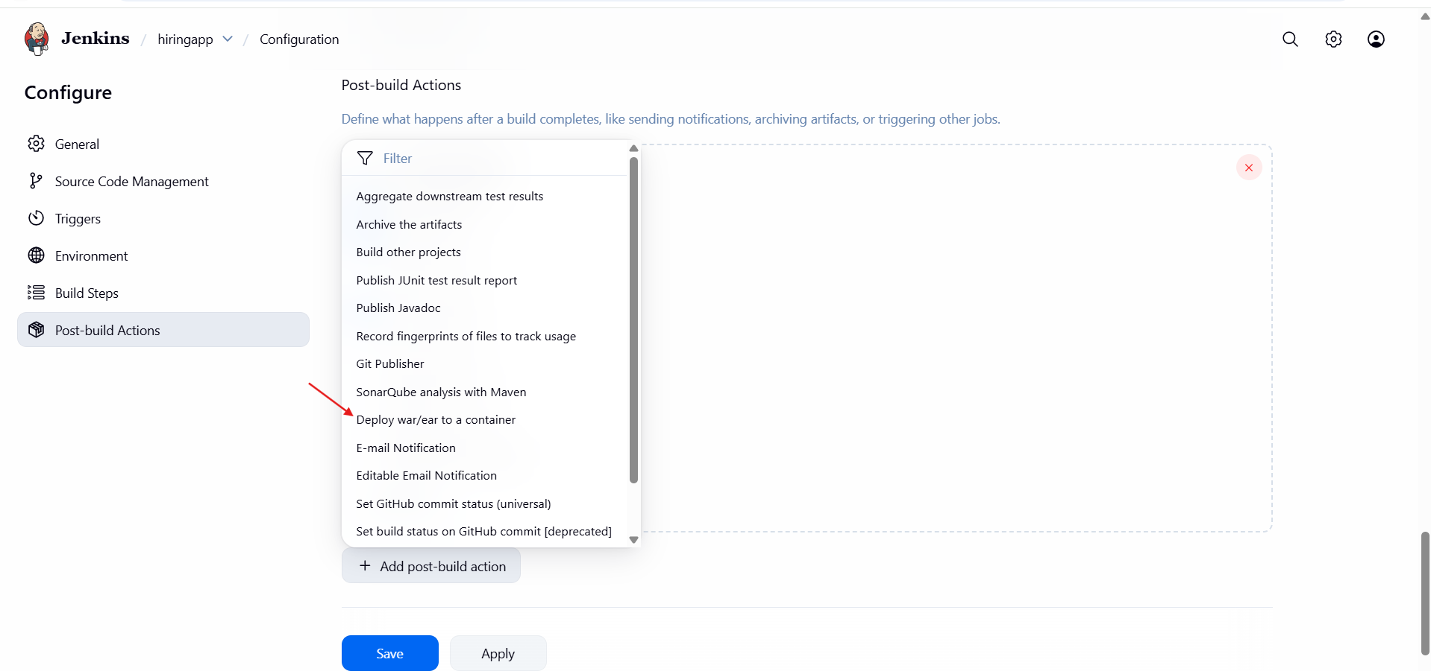

- Click Save
- Now Run Build for your job <hiring-app>

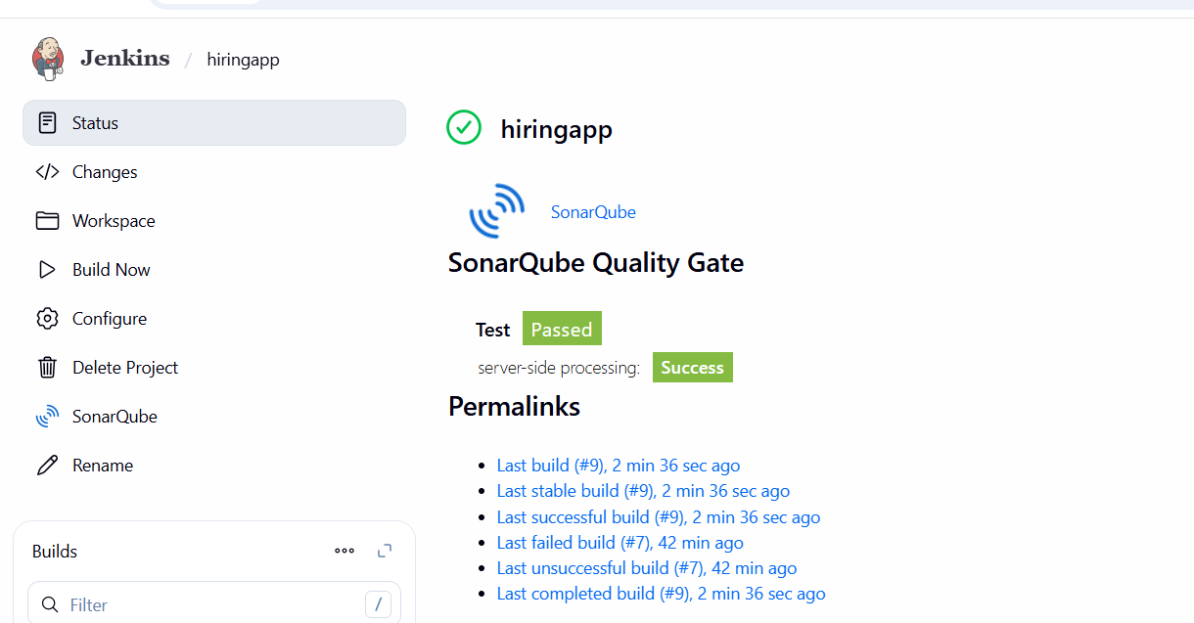
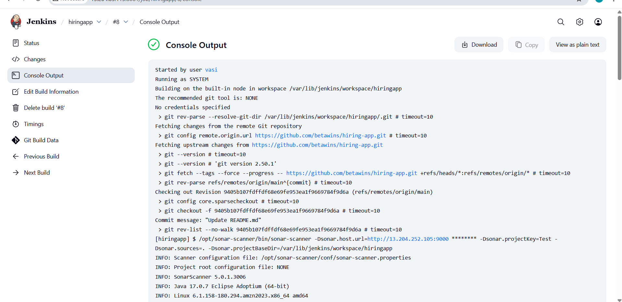
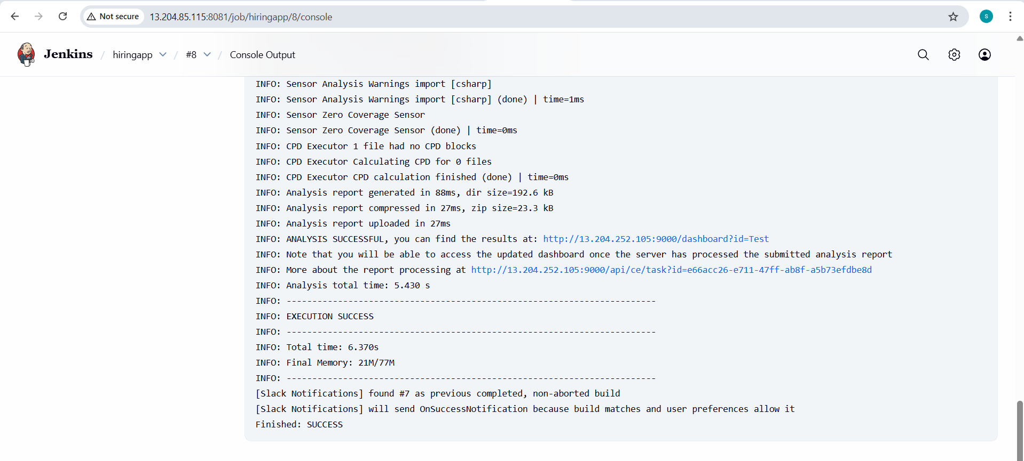
- Validation: Slack Notification

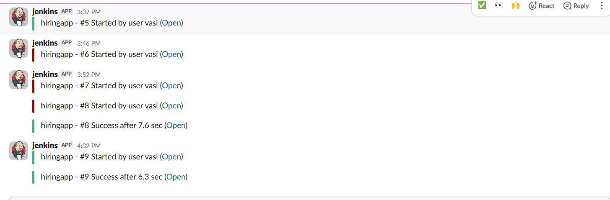

- Now our deployment is successful
- Now you can check in tomcat cli webapps one file is shown
- cd /opt/tomcat/webapps/hiring

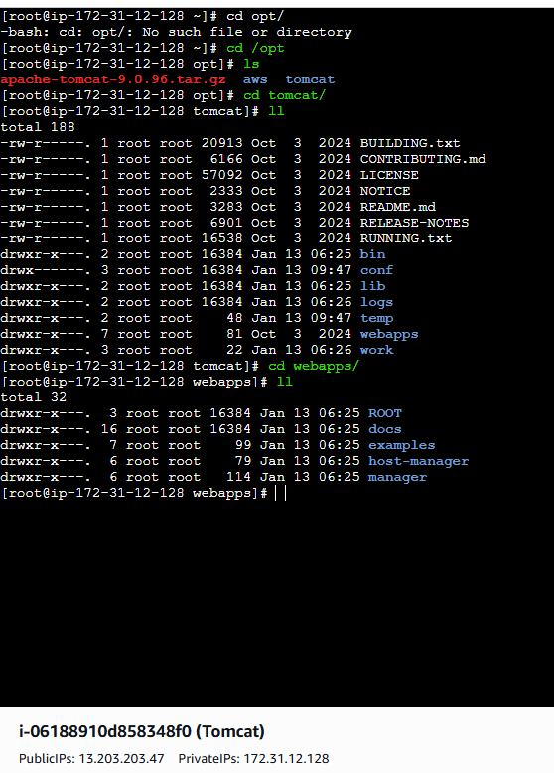

2. Setup a Jenkins CICD pipeline using Declarative pipeline using feature-1.1 branch. https://github.com/betawins/sabear_simplecutomerapp/tree/feature-1.1
stages:
Git Clone
SonarQube Integration
Maven Compilation
Nexus Artifactory
Slack Notification
Deploy On tomcat

pipeline {
agent any

stages {
stage('Checkout Code') {
steps {
git branch: 'main',
url: 'https://github.com/betawins/hiring-app.git'
}
}
}
}

- Create the new job and configure the requirements
- Job Name : Declarative pipeline
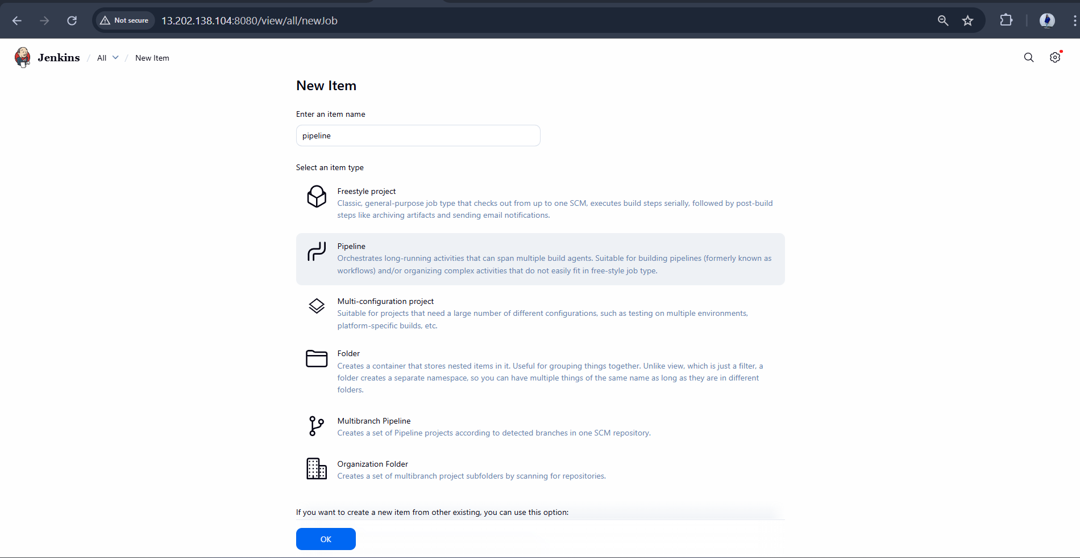
- Build it successfully
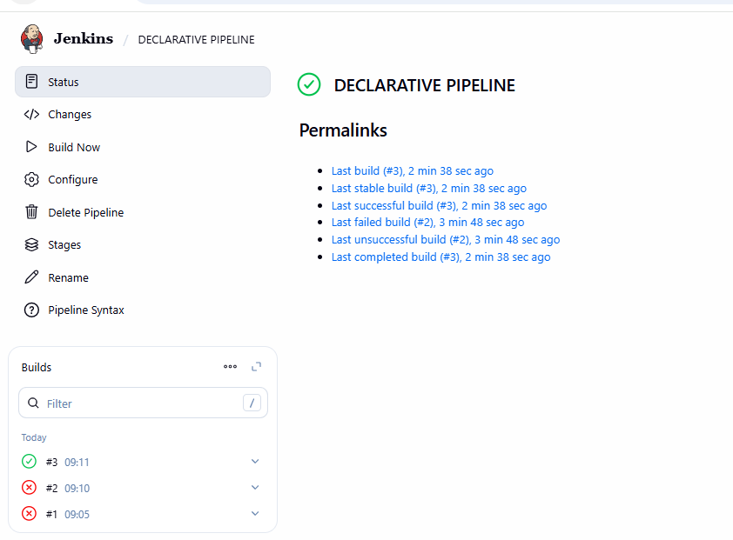
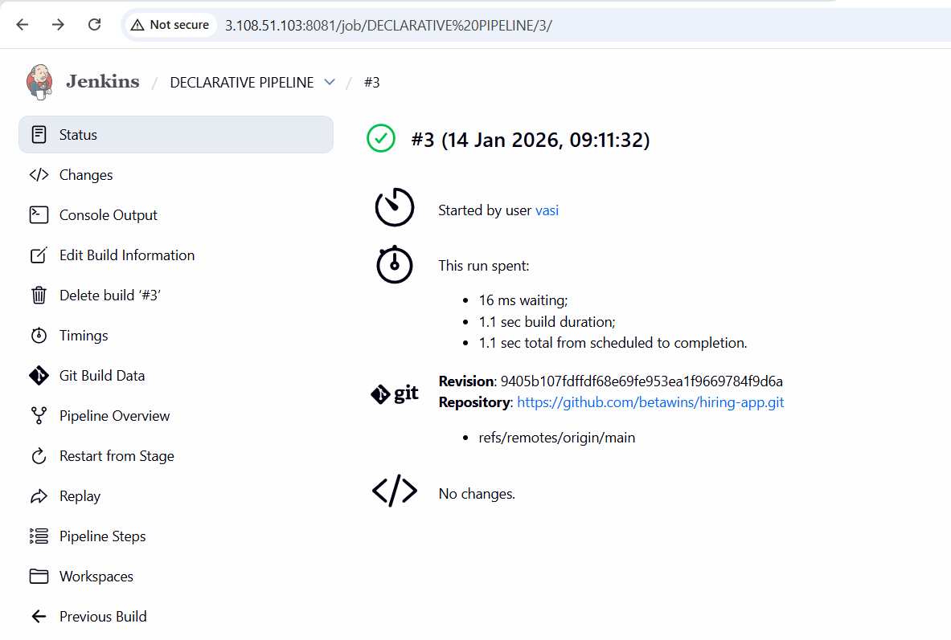
- Console output

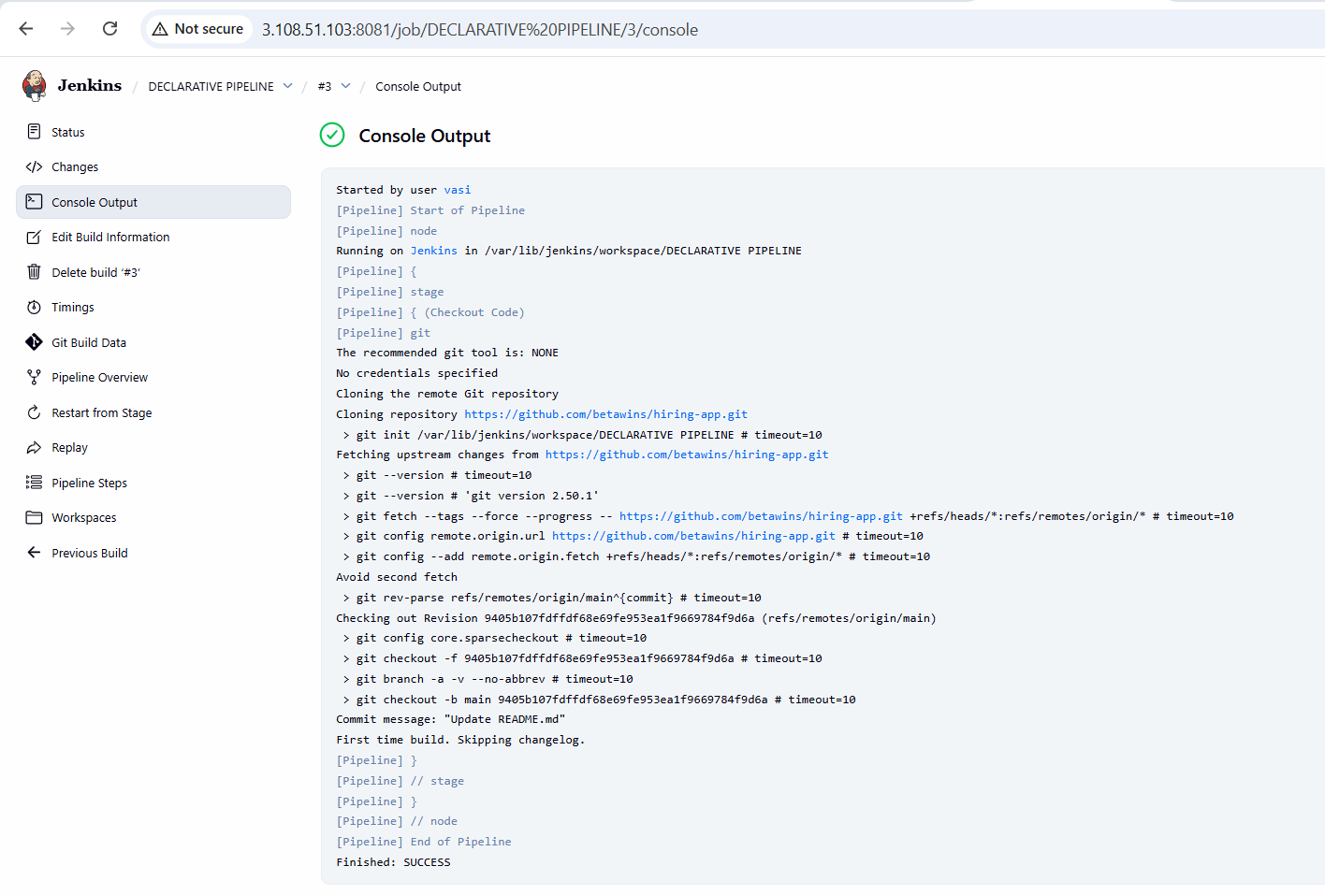

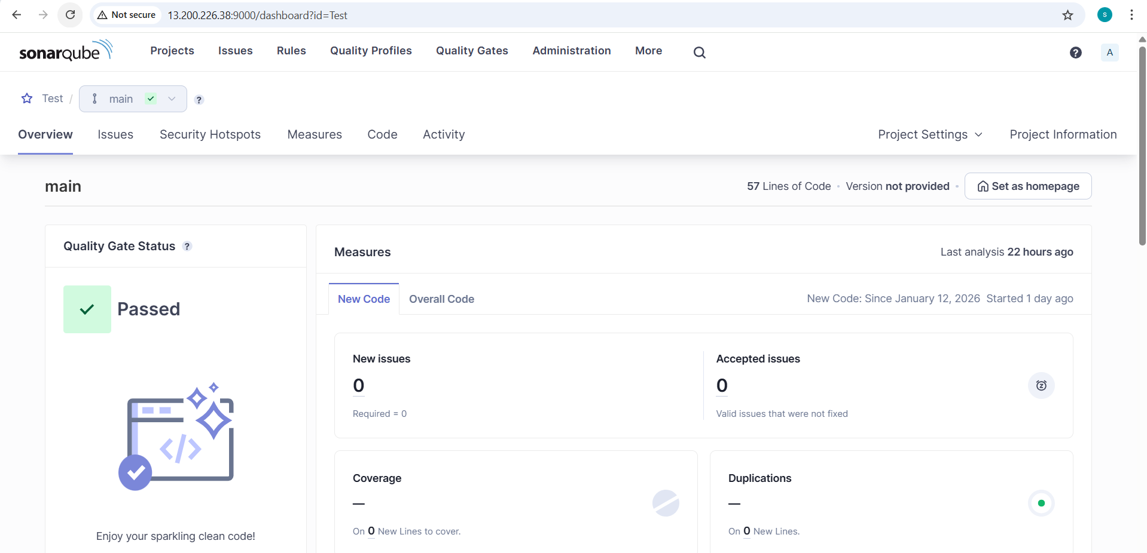

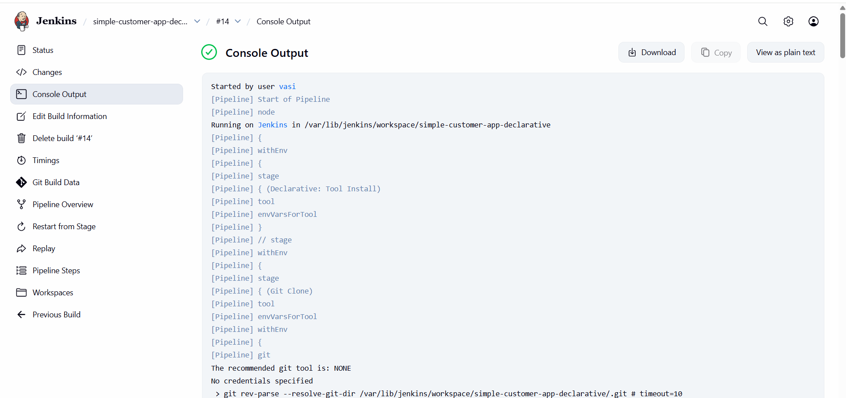
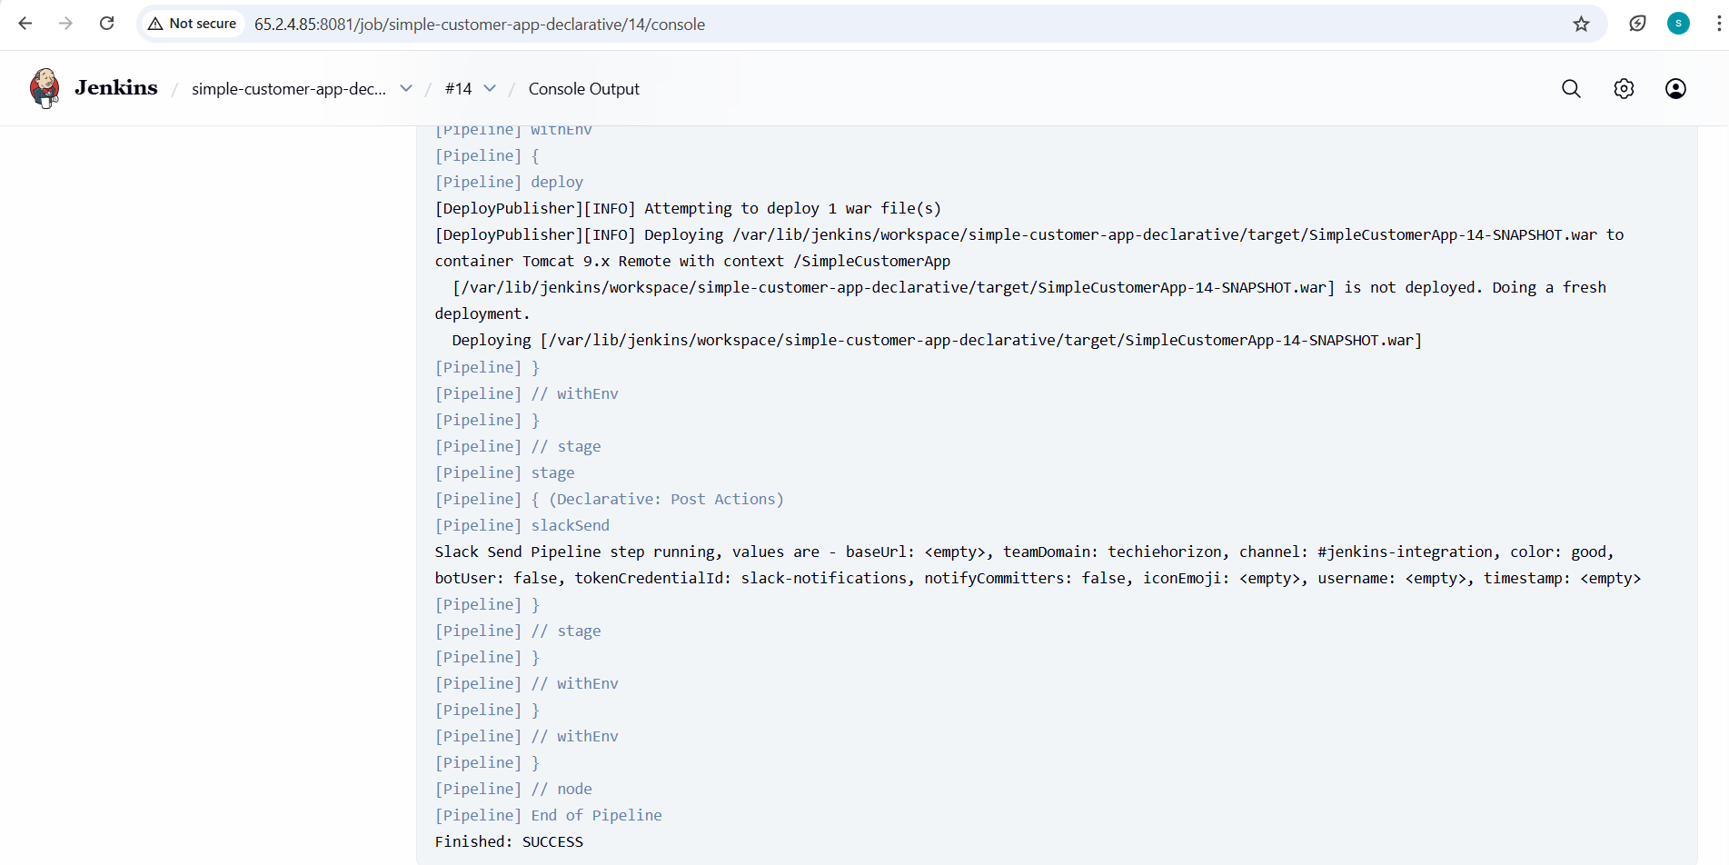

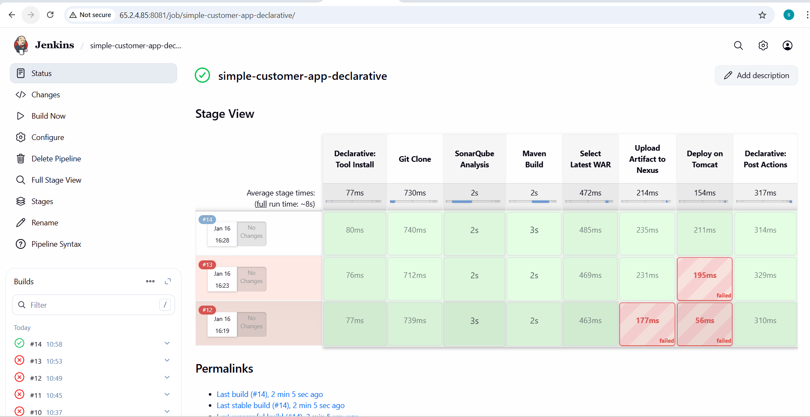
- Jenkins intergartion in slack

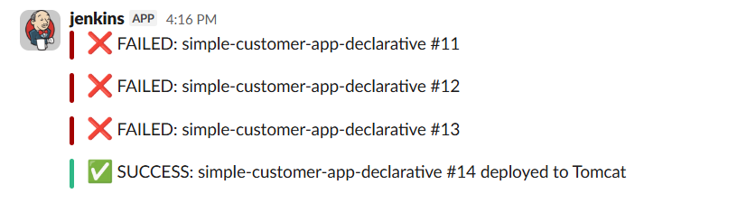

3. Setup a Jenkins CICD pipeline using Scripted pipeline using feature-1.1 branch. https://github.com/betawins/sabear_simplecutomerapp/tree/feature-1.1
stages:
Git Clone
SonarQube Integration
Maven Compilation
Nexus Artifactory
Slack Notification
Deploy On tomcat
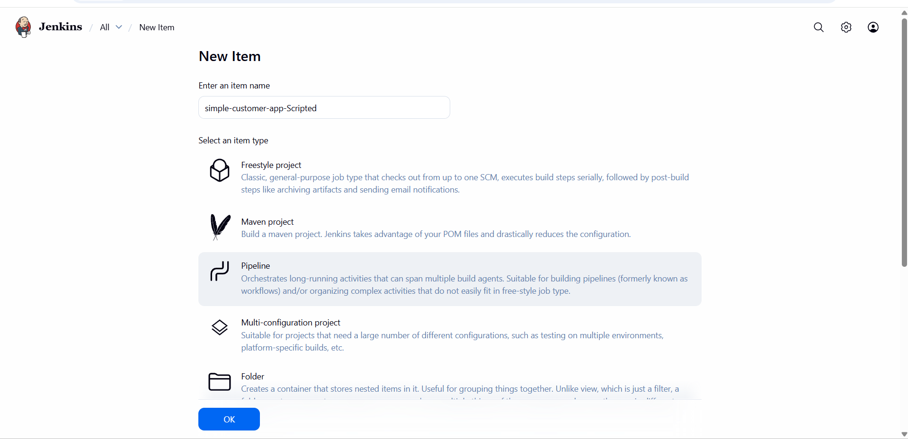
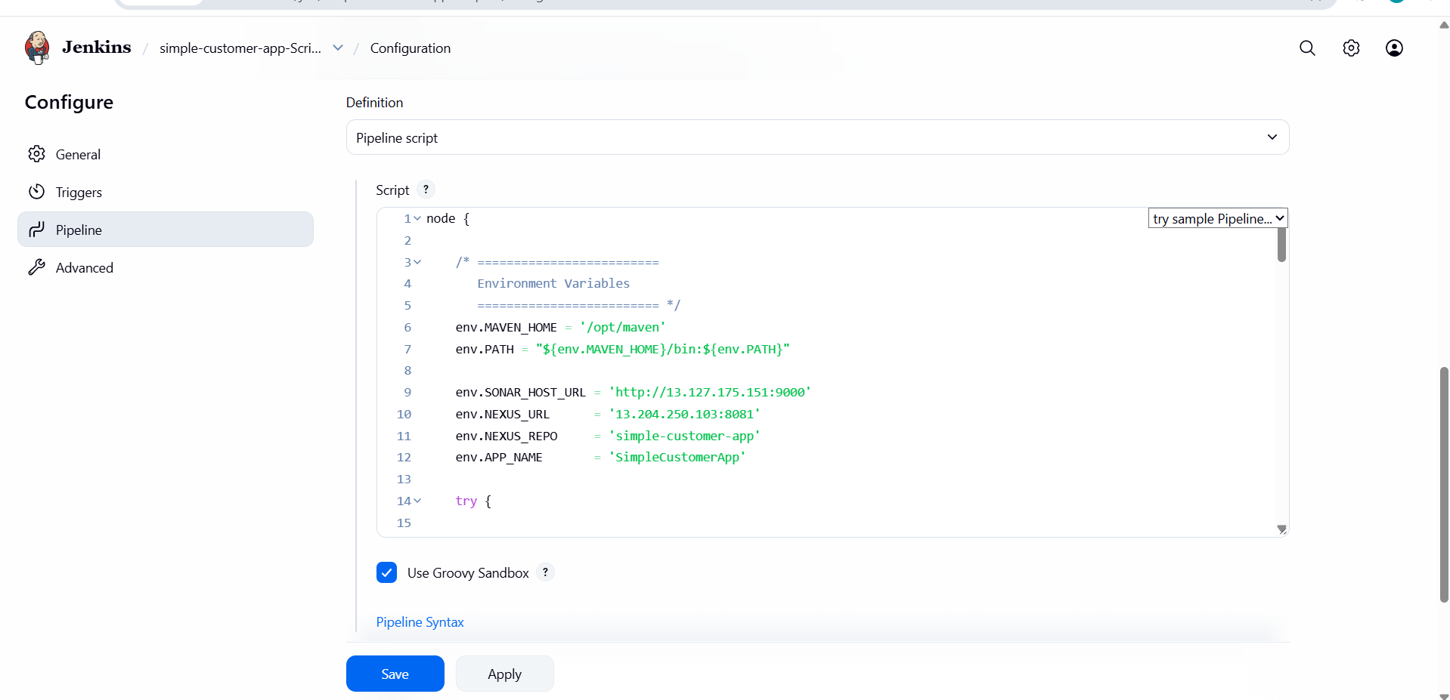
- Configure and write the script
- Build the script
it is successful

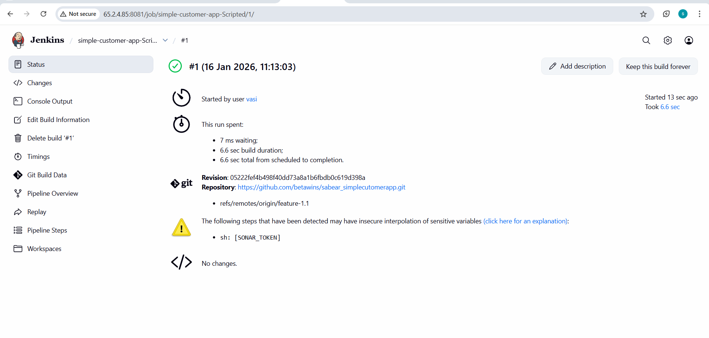
- Check the consol output
- successfull

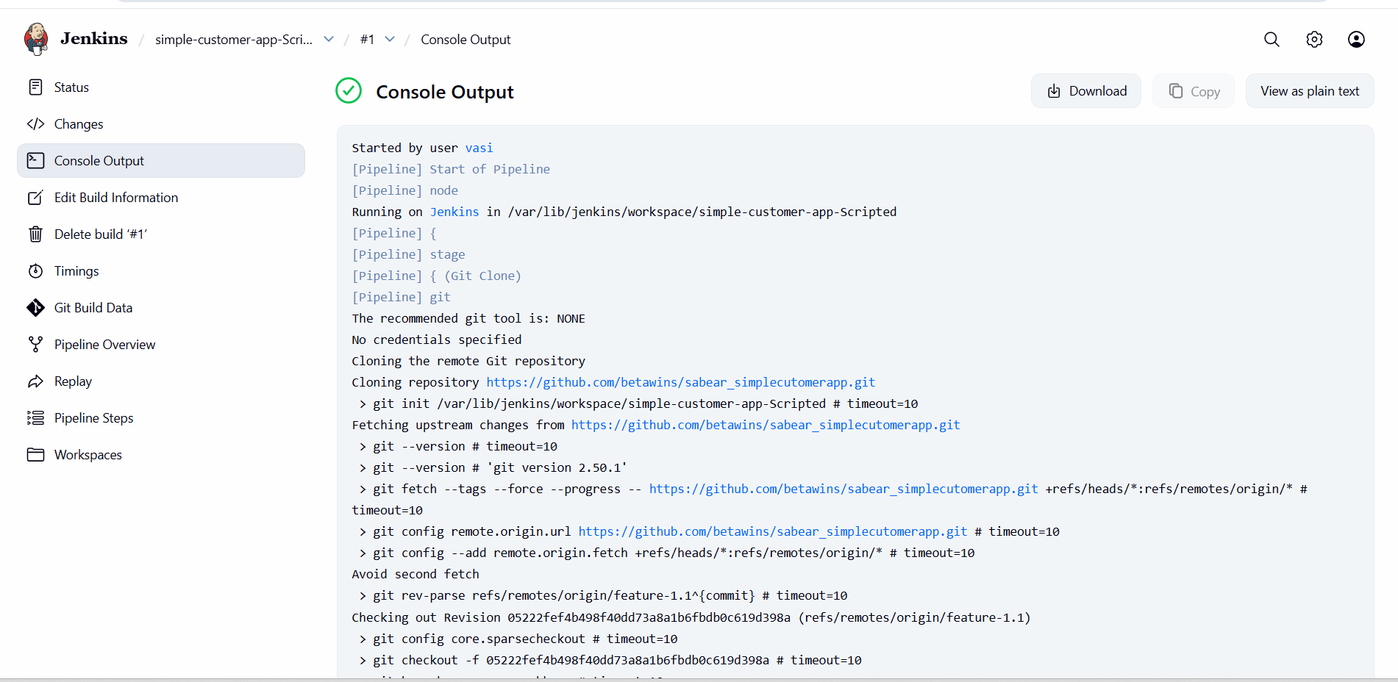
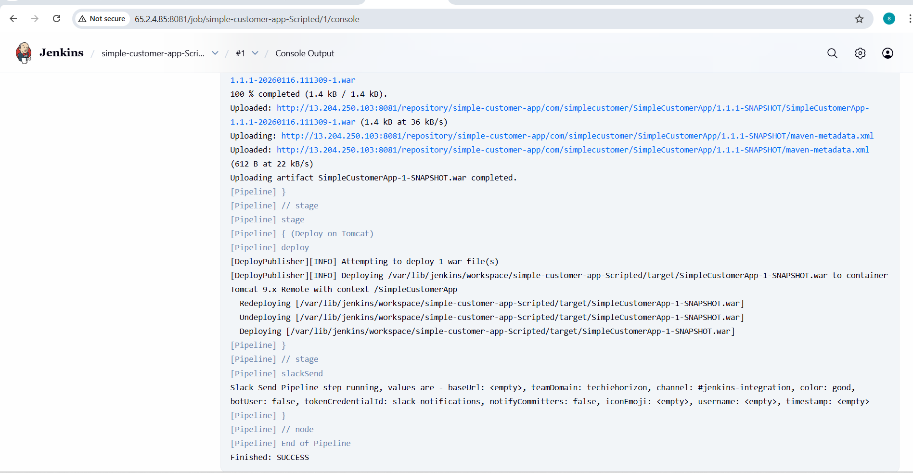
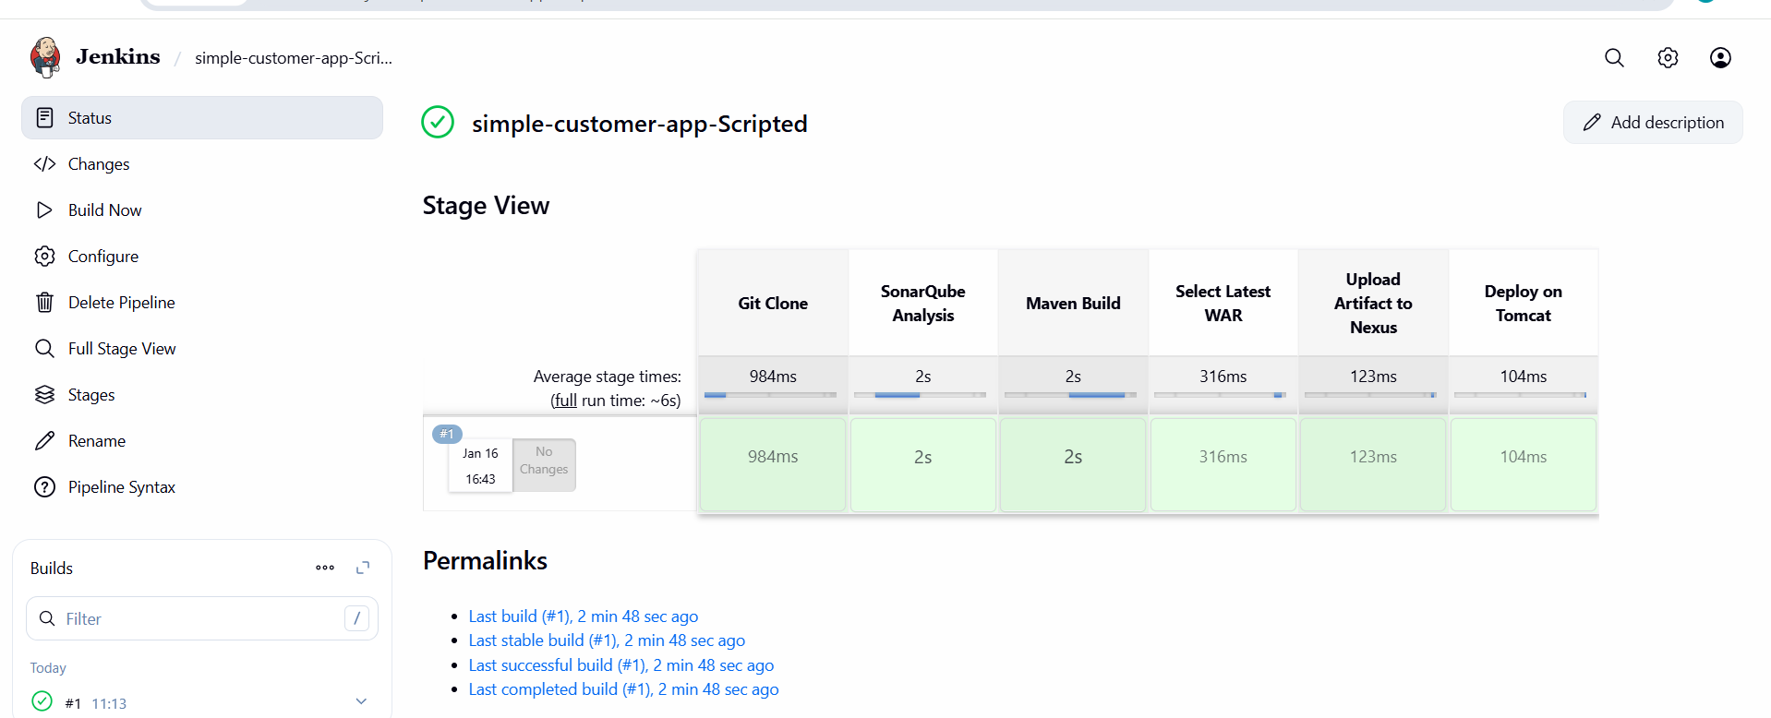
- Jenkins intergartion in slack

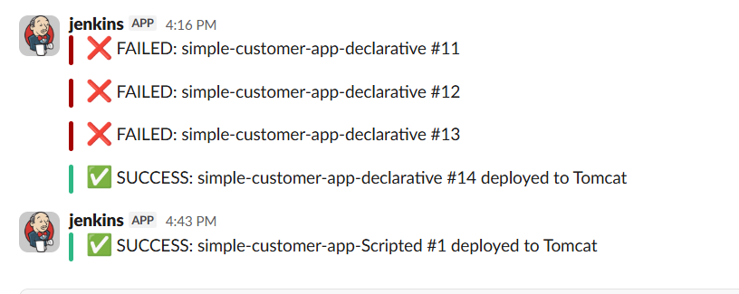

4. Write sample skeleton of pipelines.
- DECLARATIVE PIPELINE
pipeline {
agent any

tools {
maven 'MVN_HOME'
}

environment {
APP_NAME = 'my-app'
}

stages {

stage('Checkout') {
steps {
echo "Cloning source code for ${APP_NAME}"
}
}

stage('Build') {
steps {
echo "Building application"
sh 'mvn clean package'
}
}
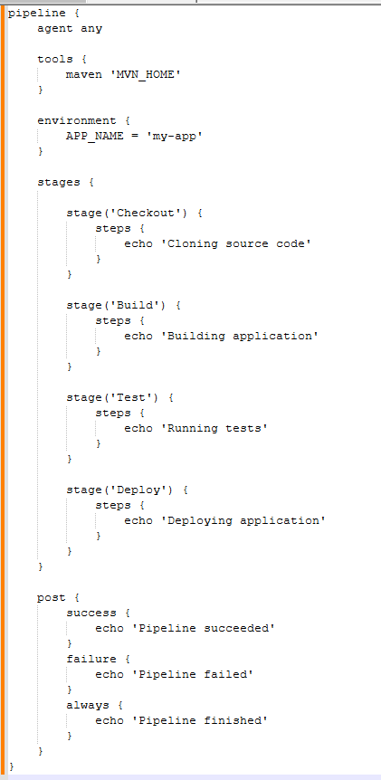

- Scripted Pipeline
node {
try {

stage('Checkout') {
echo 'Cloning source code'
}

stage('Build') {
echo 'Building application'
}

stage('Test') {
echo 'Running tests'
}

stage('Deploy') {
echo 'Deploying application'
}

echo 'Pipeline succeeded'

} catch (err) {
echo 'Pipeline failed'
throw err
}
}
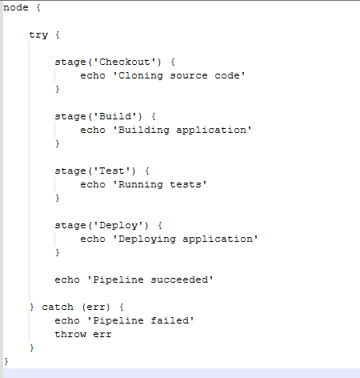

5. Create a parameterized job in Jenkins. https://github.com/betawins/spring3-mvc-maven-xml-hello-world-1.git
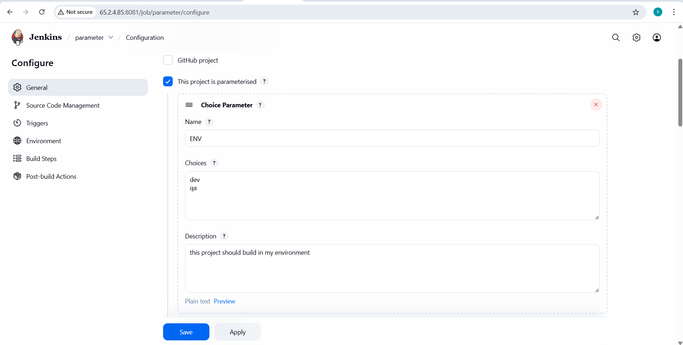
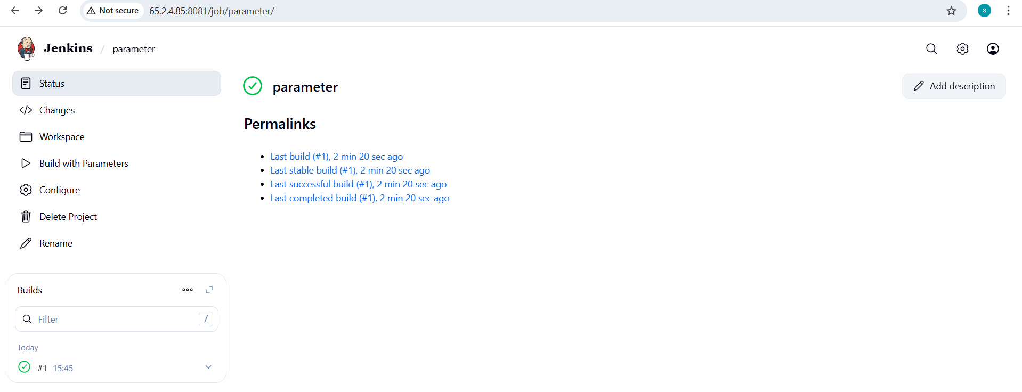
- Write the script
node {

stage('Checkout') {
echo 'Cloning the remote Git repository'

git branch: 'master',
url: 'https://github.com/syedvasiullah05-png/devops-hub.git'
}

}
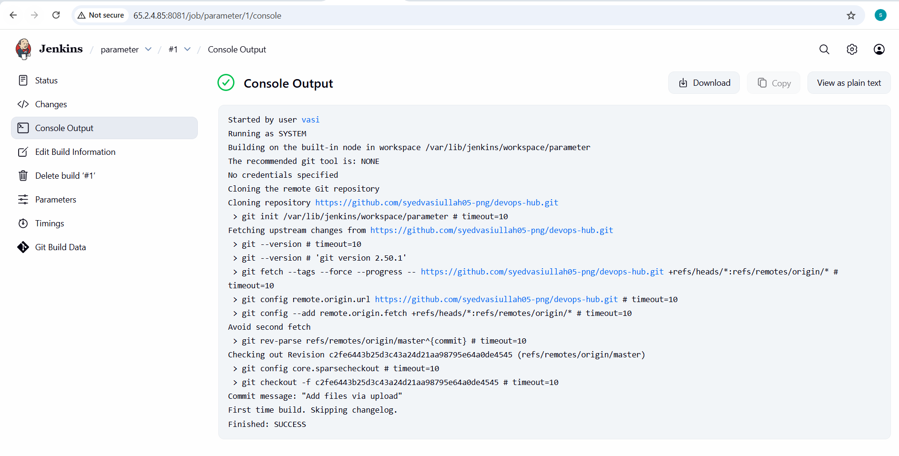
6. Setup one slave machine for Jenkins.
- Objective
- To configure two Jenkins slave (agent) machines and connect them to the Jenkins master using SSH, then verify by running jobs on the slaves
- Steps on Slave Machine-1 (slave-01)
- Steps to be done on slave
- Login to slave machine..
- switch to root user
- install jdk 11 (amazon-linux-extras install java-openjdk11)
- Create ssh-keygen
- cat id_rsa. pub › authorized_keys
- chmod 700 authorized keys
- Create EC2 Instance
- Name: slave-01
- OS: Amazon Linux 2023
- Allow SSH (22)
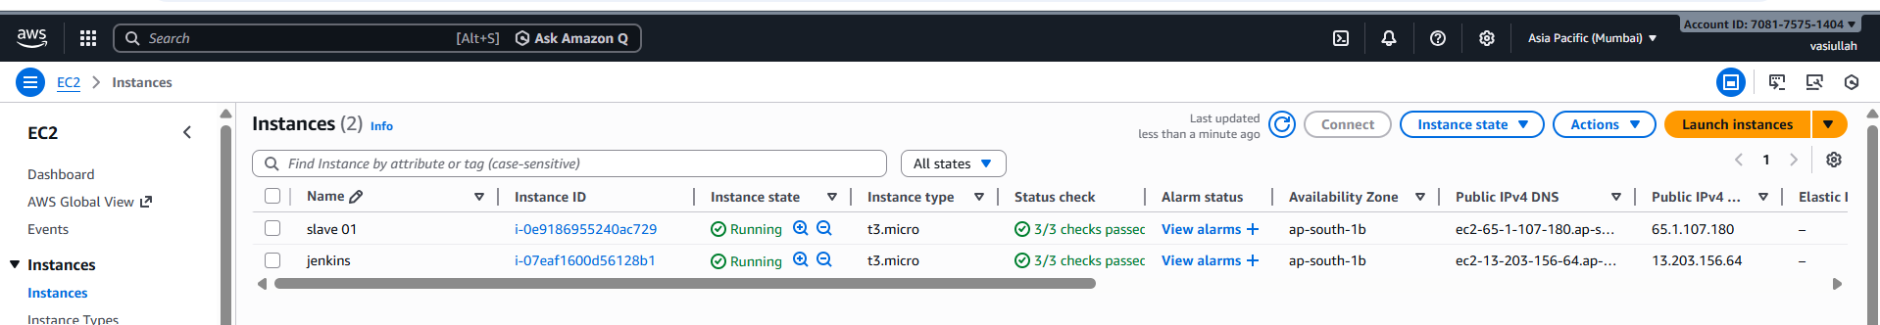
- Login & Switch to Root
- ssh -i key.pem ec2-user@ sudo -i
- Install Java
- dnf install -y java-17-amazon-corretto
- Verify: java -version

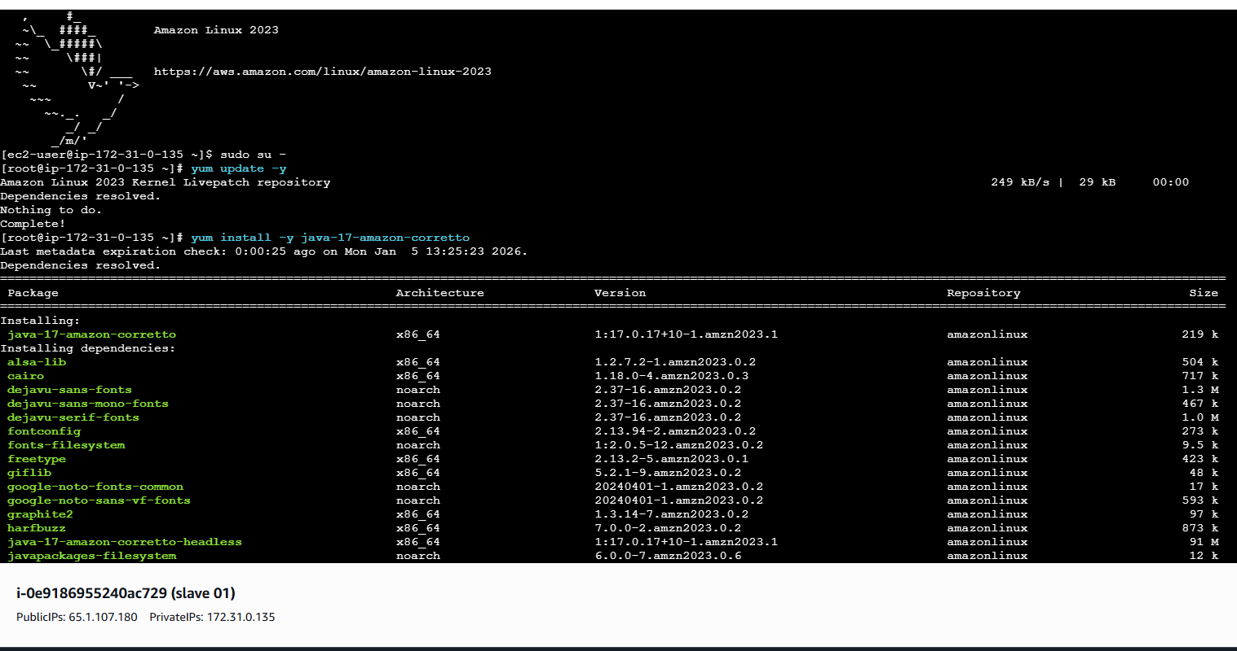
- ssh-keygen
- (Press Enter for all prompts)

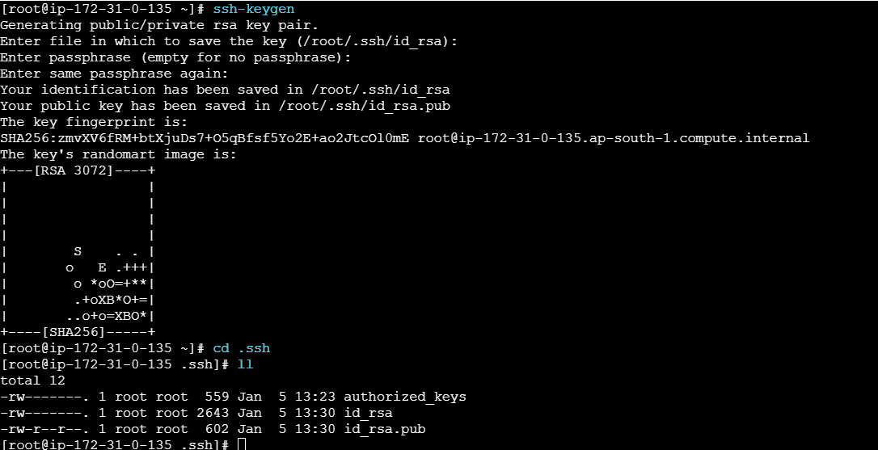

- cd ~/.ssh
- cat id_rsa.pub > authorized_keys
- chmod 700 authorized_keys

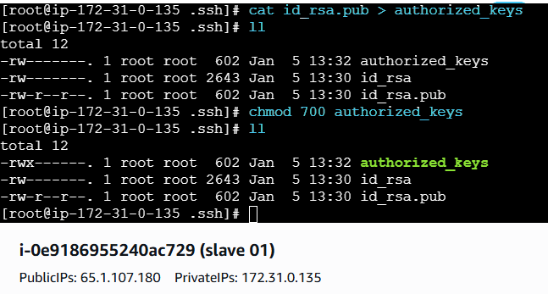
- Steps on Jenkins Master Machine
- Login to master machine
- switch to root user.
- mkdir -p /var/lib/jenkins/.ssh
- cd/var/lib/jenkins/.ss
ssh-keyscan -H 65.1.107.180 >> /var/lib/jenkins/.ssh/known_hosts
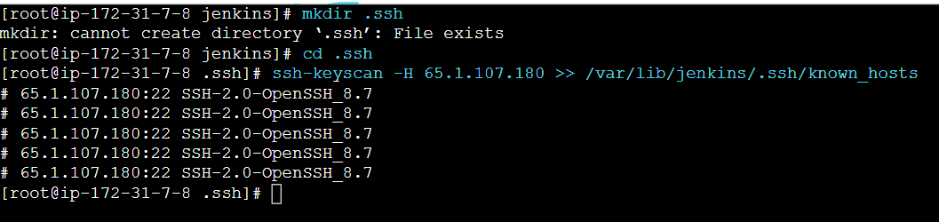
ssh-keyscan -H 65.1.107.180 >> /var/lib/jenkins/.ssh/ known_hosts
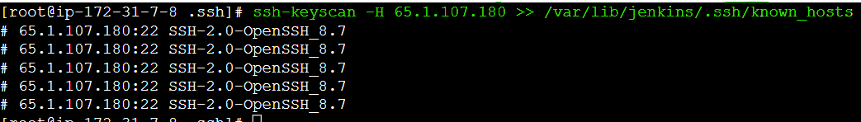
Permissions
- chown jenkins:jenkins known_hosts
- chmod 700 known_hosts

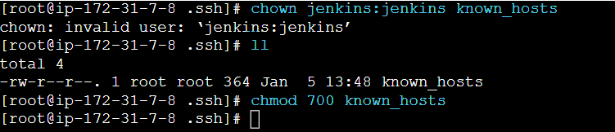
- Create New Node
• Go to: Manage Jenkins → Manage Nodes and Clouds
• Click New Node
• Node Name: slave-01
• Type: Permanent Agent
• Click OK

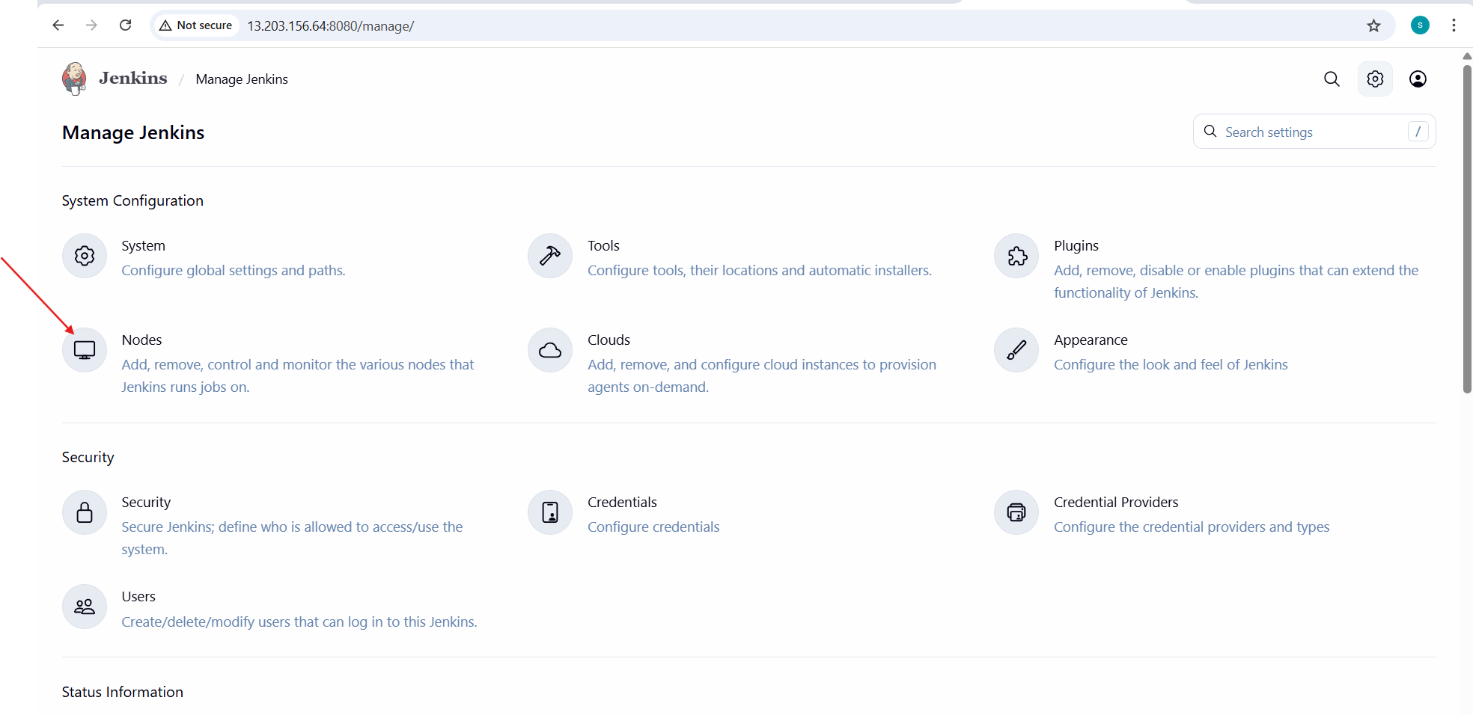

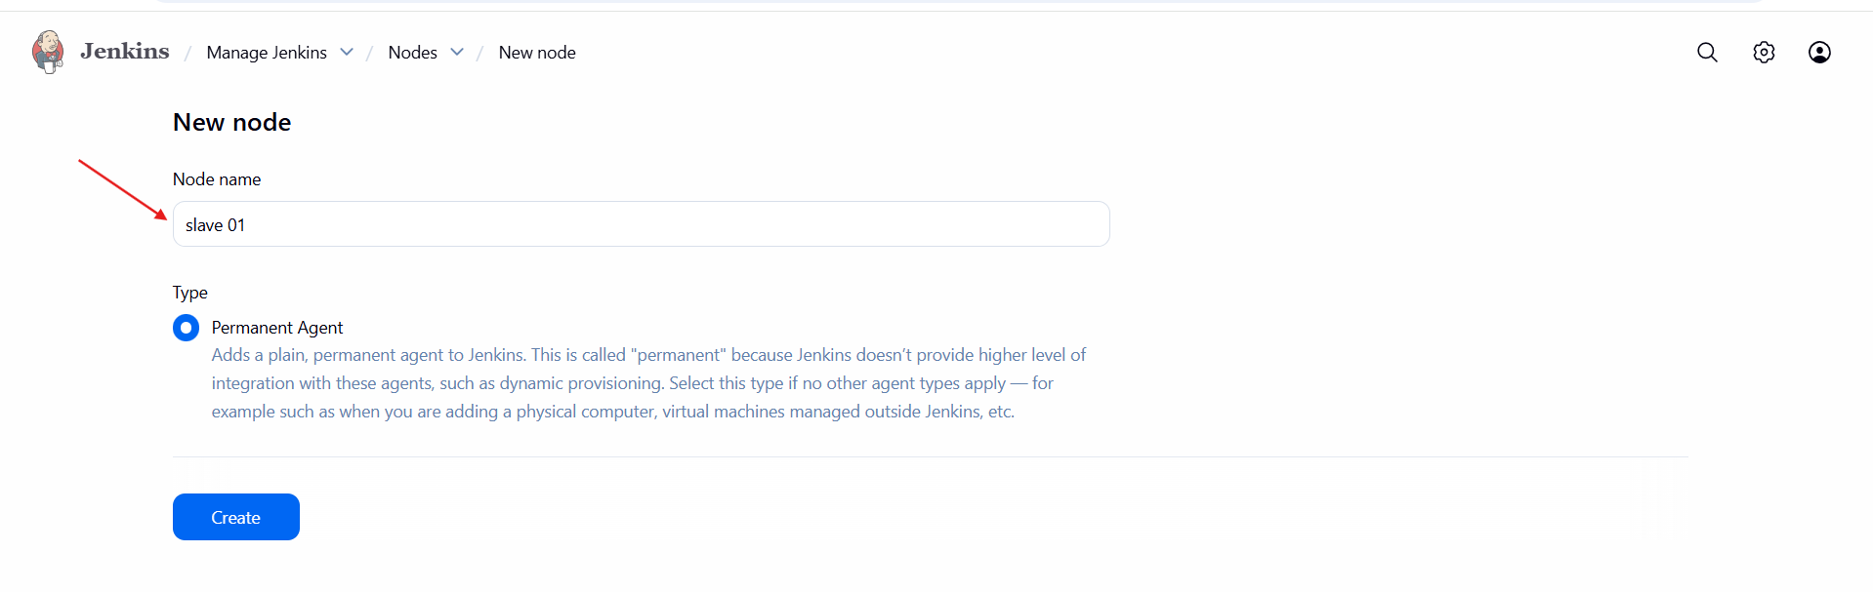
Configure Node
• Remote root directory: /home/ec2-user
• Labels: java
• Launch method: Launch agent via SSH
• Host:slave public ip
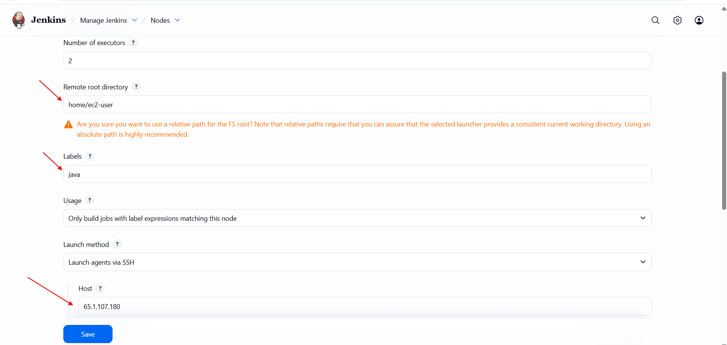
Add Credentials
• Click Add → Jenkins
• Kind: SSH Username with private key
• Username: ec2-user
• Private Key: Paste AWS .pem file content
• Save

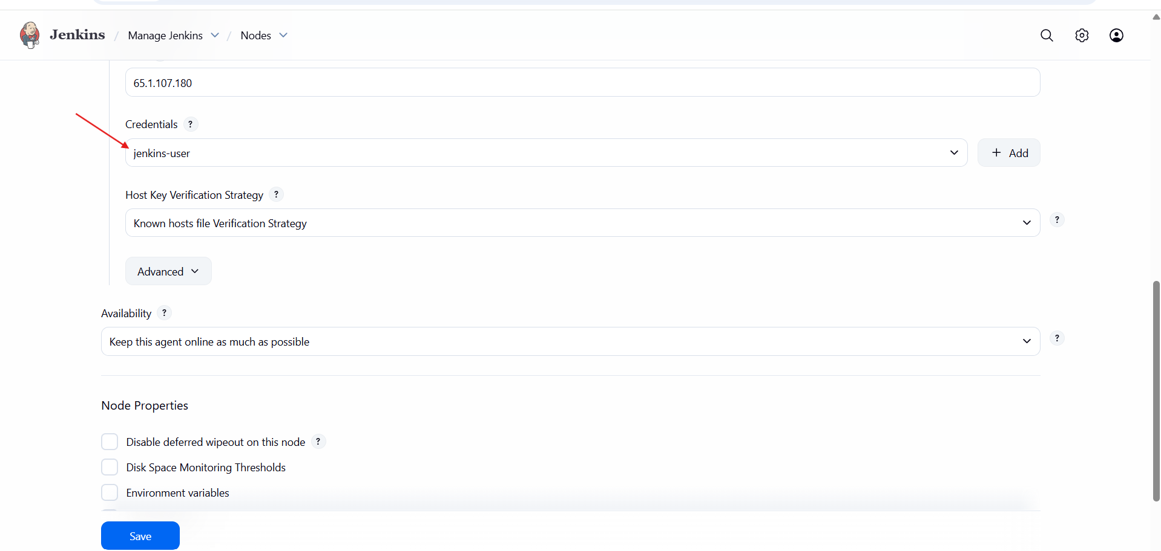

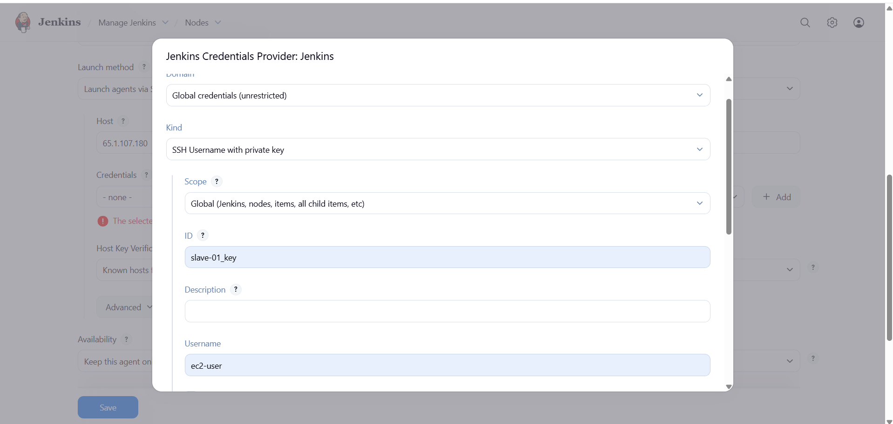

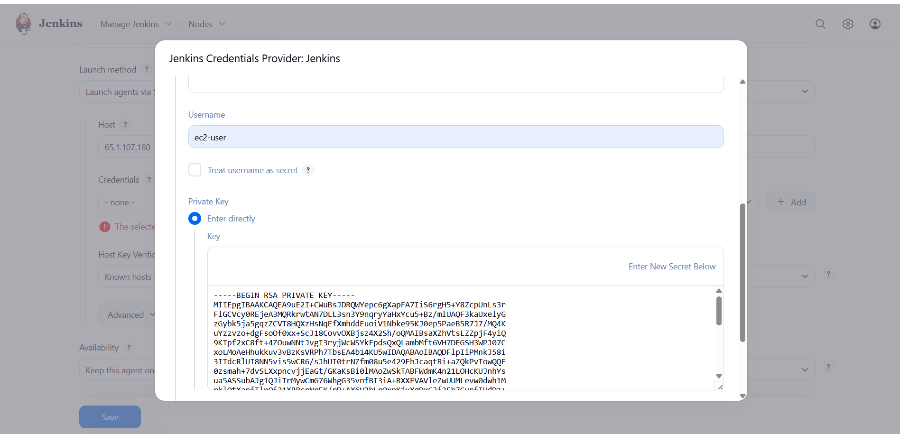
Save & Test
• Click Save
• Jenkins should connect to slave via SSH
• Node status → Online

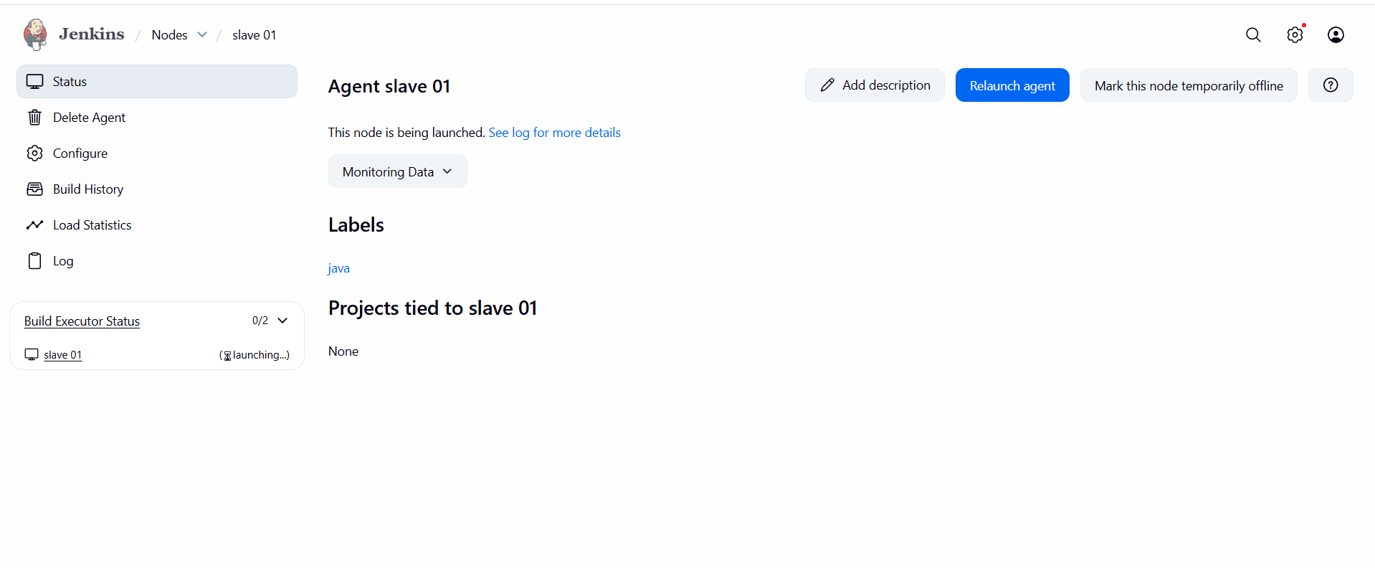
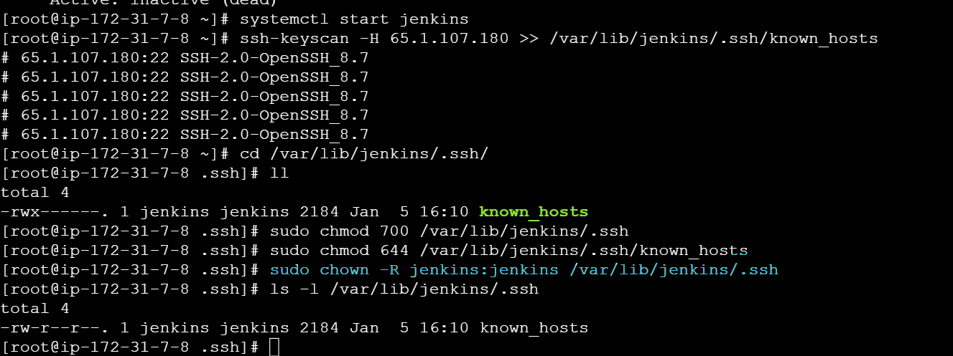

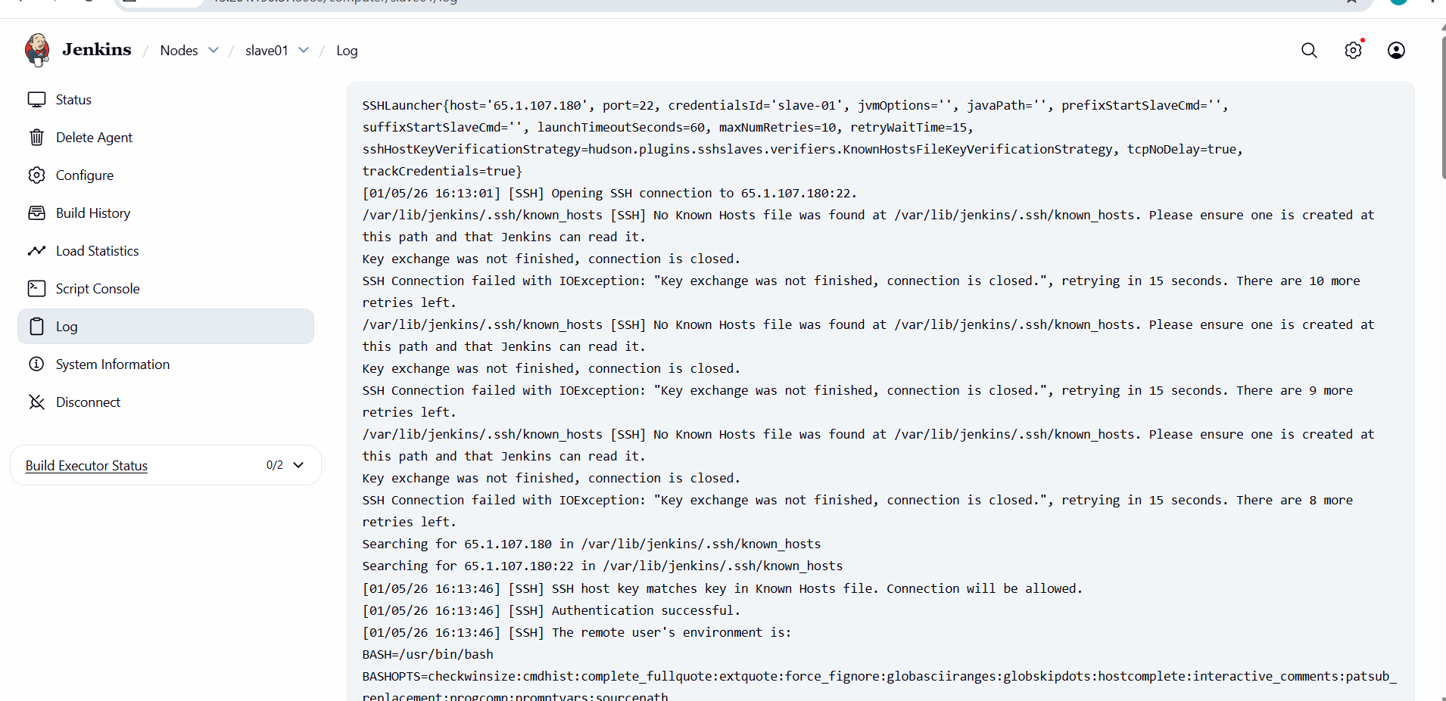
- check logs for conformation
